APPRAISAL OF INFRASTRUCTURAL FACILITIES AND ENVIRONMENTAL CONDITION OF LAM ADESHINA MARKET IN IBADAN, NIGERIA

ABSTRACT
This paper presents an overview of Lam Adeshina Cattle market in Ibadan, Nigeria in respect of its infrastructure and environmental conditions. Using simple random sampling technique, 82 traders were carefully selected for questionnaire interview which was reinforced by another set of questionnaire administered on 43 adjoining residential buildings. The major thrust of the study is to investigate the physical condition of the market, the socio-economic characteristics of sellers and also determine the impact of the market on the surrounding area. Findings divulged the deplorable condition of the market occasioned by inadequacy of infrastructural facilities and poor maintenance of existing ones; especially toilet, water supply, drainage, refuse site among others. Nonetheless, the market has positively affected its surrounding settlements, principally in the area of housing construction, employment generation, and increase in level of civilization. The paper suggests redesigning of the market in order to mitigate the identified problems. Suggestions were also made on provision of necessary infrastructure like fire station, modern toilets, bore holes, refuse facilities and production of development plan to guide the growth of adjourning area. It also suggests that the maintenance of those facilities should be entrusted in the hand of Akinyele LGA to ensure their sustainable management.
Keywords: Lam Adeshina Market, infrastructural facilities, environmental condition, socio-economic characteristics, Ibadan.
1.0 INTRODUCTION
Market is an important socio-economic and political institution in Yoruba land. More often than not, market reflects the level of economic activities and prosperity in the distribution of economy. By its nature, it plays prominent roles in the economic development of settlements no matter their location, size and category. Historically, markets came into being when the major occupation of people was predominantly farming and craftsmanship. At that time, trade-by-batter was the order of the day. Goods, especially, agricultural products formed the bulk of exchange. However, as people became more specialized, these goods were gradually taken to places used for community meetings, festivals and cultural activities as exhibition and for sales. The process of trade-by-batter around the so-called traditional centres became unexpectedly booming; hence, necessitated the erection of stalls (made of woods with thatched roof) which gradually metamorphosis to traditional markets.
By definition, market is an institution which permits socio-economic interactions of people at a particular point in time, or which may be simply referred to as a frame work of exchange (Anderson 2001; Omole and Owoeye, 2007). In most developing countries, market form an essential institution where trade takes place. The growth of most cities in Africa today is associated to certain commercial activities being performed in such area. As important as market is to socio-economic activities, cultural and political development of towns and villages; it is quite disheartening that most markets are faced with planning problems such as poor accessibility, non-conducive environmental conditions, inadequate infrastructural facilities, lack or non-existence of parking spaces and problems of road-side trading. The thrust of this study, therefore, is to appraise the level of infrastructural facility and environmental condition of Lam Adeshina cattle market in Ibadan with a view to ascertain its suitability for sustainable market operation.
2.0 THEORETICAL UNDERPINNING AND LITERATURE PERSPECTIVE
Three major theories are considered relevant to this study, they are: Growth Pole Centre, Aggregate Growth Theories and Commodity Flow Analysis. The operations of these concepts as it relates to market functions are discussed below:

2.1 Growth Poles and Growth Centres
The theory of growth pole, propounded by Francis Perroux in 1950 viewed growth pole as foci or centres in abstract economic space on which both centrifugal and centripetal forces operate to determine the development of influenced regions. In other words, they create economic actions and reactions. As quoted in Omole et al (2012), Perroux was concerned with the phenomenon of economic process and of structural change that accompanies this phenomenon. He specifically stressed that growth does not appear everywhere at the same time, it manifests itself in points of growth with variable terminal effects for the economy as a whole. In the same vein, Boudeville (1966) used this evidence to explain growth pole concept in spatial terms. He stated that a growth pole can be described as a geographic agglomeration of activities rather than a complex system of sectors. From these submissions, growth centres can be seen as selected centres in a region where economic activities are concentrated with a belief that economic prosperity generated from such centres will affect the development and influences the region overtime. On this note; the work of Penovil (1969), as quoted in Olakanmi (2000) emphasized the need to identify the potentials of growth centre which could normally be employed for identification and accessibility of natural resources, market quality, importance of infrastructure, size of settlement, socio-political factors, favourable developmental agents like investors and entrepreneur both within and outside. Presently, Lam Adeshina market is one of the recognized markets in South-western Nigeria whose activities and scope, in term of patronage, cut across both national and international boundaries. The notable growth that spread over the region hinges on the activities of this market as it enhances the economic base of the population as well as improved the consumption pattern of the region.
2.2 Aggregate Growth Theories
Aggregate growth theories comprise mainly the international trade theory, the sector theory and the export or staple theory. As comprehensively documented in Ezenagu (2001) and Omole, et al (2012), aggregate growth theories focus on the understanding of the factors that influence the growth of specific areas within the economic or geographical space. These theories further envisage the fact that development could either be as a result of internal or external determinants or combination of which has a cumulative effects on the development of geographical space overtime. The major internal determinant could be referred to distribution of factors of production such as land, labour, capital and entrepreneur while the external determinant is as a result of demand and supply of the commodities from other areas. The emphasis therefore is on the internal determinant, which is a relevant theory applicable to the study of Lam Adeshina market as it influences development in the geographical space of Ibadan region.
2.3 Commodity Flows Analysis
The flow of commodities between places is a common phenomenon which occurs at various levels between two states, two local areas, and even between two countries. Commodity flow has its origin from spatial variation of demand and supply both of goods and services. As a result of improved transport facilities, commodity flows has increased overtime in area, scope and volume. Commodity flows is basically a factor of resource endowment and demand. This idea is well illustrated in Ezenagu (2001) which shows that the existence of supply and effective demand brings about interactions, especially in the form of commodity flows; simply because there is usually a spatial variation in resources endowment and spatial variation in the supply and demand of commodities. This theories form a major preliminary study to effective regional development planning which is employed for the study of commodity flows in Lam Adeshina market as it influence its development over time.
Locational framework of markets, as it applicable to this study, generates activities that create sufficient economic agglomeration to be shared with adjoining local (or lower order) markets. The location of the major growth centres, as rightly identified in Onokerhoraye (1976) as well as in Omole and Owoeye (2007), relates to south-west cluster, the Federal capital territory, the Port city of Metropolitan Lagos, Port-Harcourt, Aba, Onitsha and Enugu as well as Kano, Zaria and Kaduna in the Northern part. These dominate the major market centres in the country. The primary criterion for existence of these high order market centres has always been their potential for economic viability, locational advantages for efficient and long-run operation for economic activities. The locational spatial frame work provided by these top levels of market hierarchy can then be used to develop series of intermediate rural markets as well as border markets that can at least serve 20,000 rural dwellers. This is in line with the concepts of the range of a good and threshold population in the popular central place theory. Therefore, the study of markets for better development could be selected on the basis of analysis of their location, socio-political and economic assets. According to Onokerhoraye (1976), markets should be located in areas accessible to the existing transport network especially motor-able roads.
In Nigeria, development of markets is as old as the history of towns and villages, which originated from the establishment of permanent settlements as dated back to the Pre- and Neolithic agricultural revolution period (Omole et al, 2012; Oshundeyi, 2012). This was brought about by the increase in food production due to the systematic cultivation of edible plants and transformation from anomalism to permanency of residence (Northern and Haskou, 1975). According to him, the social unit was able to grow into a clan in the course of time and latter grew into large settlements and technological inventions like the discovery of farm implements which led to the production of food surpluses and other agricultural products. This invariably led to the beginning of trade and evolution of the first market where goods and services were exchanged between individuals and close hamlets. During the pre-colonial periods, classification of market centres was based largely on the hierarchical structure of the various towns and villages. This hierarchical difference was reflected on the functions which the various towns performed. Markets were therefore classified on the basis of functions and variables like scale of transaction, commodities sold, periodicity, nature of growth, organization and catchments area.
3.0 RESEARCH SETTING, MATERIALS AND METHODS
The Ibadan Cattle Market was initially located at Bodija in Ibadan North Local Government Area, about one kilometer from the University of Ibadan, along the road to the State Government’s Secretariat. It was the main recipient and distributor of cattle moved from different parts of northern states to Ibadan metropolis and some parts of the Yoruba south-west. The main Kraal for receiving of cattle from the northern states was later moved to Akinyele after the 1999 Bodija ethnic conflict which existed between the Hausa cattle traders and the Yoruba marketers (Filani, 2005). The then Governor of Oyo State, Alhaji Lam Adeshina, decided to move the Kraal to Akinyele, about 19 kilometres north of Ibadan along Ibadan-Oyo-Ilorin road. A place that is more spacious than Bodija market and far from the Bodija non-cattle traders. The Kraal at Akinyele was then named after the Governor as Lam Adeshina Cattle Kraal. Till today, Akinyele is the main Kraal for initially receiving cattle from the northern states while Bodija remains the main market for the slaughtering and marketing of cattle in the Ibadan metropolis and in some parts of Yoruba south-west. Figures 1 – 3 show the location of the study area in both national and local settings.
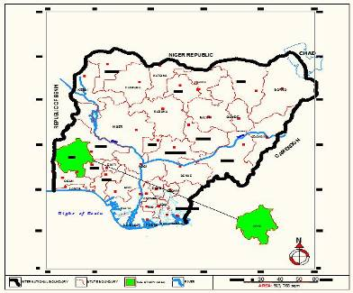
Figure 1: Map of Nigeria Showing Oyo State
Source: Google Earth, 2012 (Reproduced by Authors in AutoCAD version)
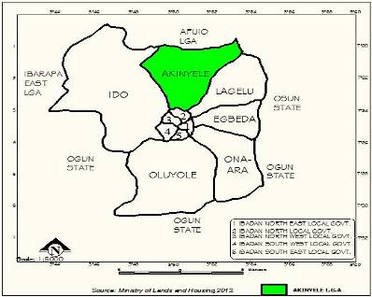
Figure 2: Map of Ibadan metropolis showing its 11 Local Govt. Areas.
Source: Ministry of Lands and Housing, Ibadan; 2013

Figure 3: Map of Akinyele LGA showing The Study Area
Source: Ministry of Lands and Housing, Ibadan; 2013
As a necessary prelude to the study, a reconnaissance survey was conducted for the researchers to get familiar with the study area. This was later followed by series of other field surveys conducted among which include questionnaire administration, personal observation and photo-prints. The types of data required for a study of this nature usually concerns the historical development of the area and various activities carried out in the market, the movement pattern in and out for marketing activities as well as condition of existing facilities in the market. In order to ensure proper coverage of activities in the area, two sets of questionnaires were used to elicit information from residents in adjoining residential area and those administered on sellers who are direct and principal users of the market. A total number of 205 sellers were found on space and stall allocation records made available by the administrative department of the market. Out of this; 82 traders, representing 40.0% of the 205 were selected for interview using simple random sampling technique. Besides, all the 43 buildings located around the market, at least a household per building, were interviewed in order to determine the perception of the residents about the effect of the market on the neighbourhood. Data collected were analyzed and interpreted using a descriptive Statistical Package for Social Scientist (SPSS – version 17). Results were finally presented in form of tables, charts and photo-prints.
4.0 RESEARCH FINDINGS AND DISCUSSION
4.1 Socio-Economic Characteristics of Sellers
As shown in Table 1, majority of the sellers in the market fall within the active age group of 21 to 60 years. This accounts for 80.49% of the sampled respondents. The age group under 20 take a minimal portion of about 12.19%, majority of who are mere appetites or younger ones who assist their parents in the business. The simple explanation for this could be that in cattle business, one needs to be financially stable at least to start the business, hence the possibility that one might need to save money for some years before venturing into this business. Statistics also show that those above 60 years of age constitute only 7.32%. This proportion may be due to biological retirement age where-by one is no longer agile to cope with this kind of business.
Table 1: Age and Sex Distribution of Sellers in Lam Adeshina Market
Variables | Frequency | Percentage
Age: 20 years and below  21-40 years  41-60 years  Above 60 years | 10  22  44  06 | 12.20  26.83  53.66  07.32
Total | 82 | 100.00
Sex: Male  Female | 54  28 | 65.85  34.15
Total | 82 | 100.00
Source: Authors’ Field Survey, 2012

The sex distribution favour male gender as shown in the Table. Over 65% of the total sellers in the market are of male folk, while just 34% are of female folk. This distribution is not surprising because a cattle business is believes to be sex picking business. A business that is traditionally believes to be for the male folk because of its nature of dealing with life cattle. The 34.15% sellers associated with female are those on retail business, who only sell beef in the market as they cannot handle life cattle. Besides, the traditional and religious belief of Hausas who are the major cattle sellers in this market does not encourage women in any activities that would expose them to public interaction.
4.2 Classification of Traders by Commodities Sold in the Market
Although this market was establish specifically to deal with the sales of life cattle; yet, other trading activities had sprung up around the market which has lead to the formation of several associations that now lay claim to certain rights and responsibilities within and around the market’s environment. Some of these associations include: Cattle's sellers association, cattle buyers association, butchers association, goat and sheep seller association, food vendors association, shops owners association, and Landlords/land owners association. Information collected in the market, as shown in Table 2, reveal that commodities such as life cattle, and sheep and other petty activities dominate the products sold in the market in proportion of 34.15% of cattle, 21.95% of goat and sheep while other trading activities like cheese, food, pure water, sugar cane and others cater for the rest 14.63%.
Table 2: Distribution of Commodities sold in the market
Commodities | Frequency | Percentage
Meat  Cattle  Goat & Sheep  Petty Trading | 24  28  18  12 | 29.27  34.15  21.95  14.63
Total | 82 | 100.00
Source: Authors Field survey, 2012
4.3 Land Use Analysis and Layout Pattern of the Market
Land use distribution is a principal determinant that influences the functional efficiency of a market. The analysis of existing land use pattern of Lam Adeshina cattle market revealed that the major land use include commercial, circulation and vacant land as shown in Table 3 in their varying proportions.
Table 3: Land use Distribution in the Market
Land Uses | Area coverage (Hectare) | Percentage
Circulation  Infrastructure/Public utilities  Commercial  Vacant lands | 5.81  4.29  8.02  25.88 | 13.20  09.75  18.23  58.82
Total | 44 Hectares | 100.00
Source: Authors Field Survey, 2012
4.4 Condition of Infrastructural Facilities in the Market
- Toilets: Planning standards stipulate that toilets should be located within a minimum reasonable walking distance and to serve particular threshold population of people. For commercial development of this nature, there should be provision for one toilet to serve 15 to 20 people. In relation to the study area, there are four existing toilets in the market to serve 205 registered traders, instead of ten. Apart from the paucity of this facility, they are poorly managed. It appears that the #20 charge on each user is not sufficient or not properly managed for the regular upkeep of the facility.
- Water Supply: In commercial areas, water is required for drinking, cleaning up and fire fighting purposes. The quantity of water to be supplied is expected to be circulated on 115 litres per capital per day in relation to World Bank standard. Hence, about 5,535 litres are needed for consumption per day. Findings revealed the inadequacy of this facility and unhygienic source of the existing water supply. The main source available in the market is hand-dug well located in unkempt environment which does not guarantee safe drinkable water. Besides, there is no water reservoir in the market area. People source for water from the only hand-dug well provided by the local government and water vendors as alternative, whose source one cannot determine. The water supply within the market is very poor and people do spend huge amount of money to fetch water. This has compelled many users to fetch water from stagnant pond around the area. A typical example is shown in plate 1.
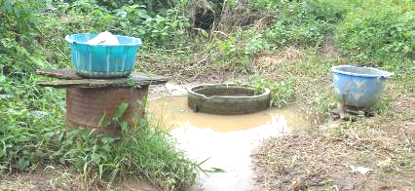

Plate 1: Hand-dug well (almost becoming a stagnant pond) as source of water in the Market area
Source: Authors’ Field Survey, 2012
- Roads: In commercial areas, there is need for easy access to shops, stalls and other activity areas so as to ensure efficient means of movement of people for effective patronage. Planning standard stipulates that market should have, at least, a distributor road of a minimum of 12 meters carriage way width, local distribution roads of 11 meters width, and access roads of minimum of 10 meters width. All these types of road in the market maintained the required standard but most of the roads are in sorry state as most are not tarred and become slippery during rainy periods.
- Refuse Disposal: It is mostly worrisome that there is inadequate provision for waste receptacles in the market. The paucity of this facility is particularly responsible for the indiscriminate dumping of refuse within the market premises. This has made the market to be stinking with bad odours, especially the animal waste, thereby releasing offensive odours in the market. In every commercial area, at least, a refuse receptacle should be provided for 10 to 15 shops which should be within 0.9 to 1.37meters away. Besides, it is necessary to have a general collection centre where all garbage of the commercial area collected is dumped before final disposal. This arrangement is lacking for proper sanitary of the area.
- Canteen: The comfort-ability of a market depends on the availability of canteens, made available within a reasonable distance. There are two (2) blocks of canteens strategically located within the market; only that the environment in which they operate are not hygienic enough. See plate 2 for a typical example.
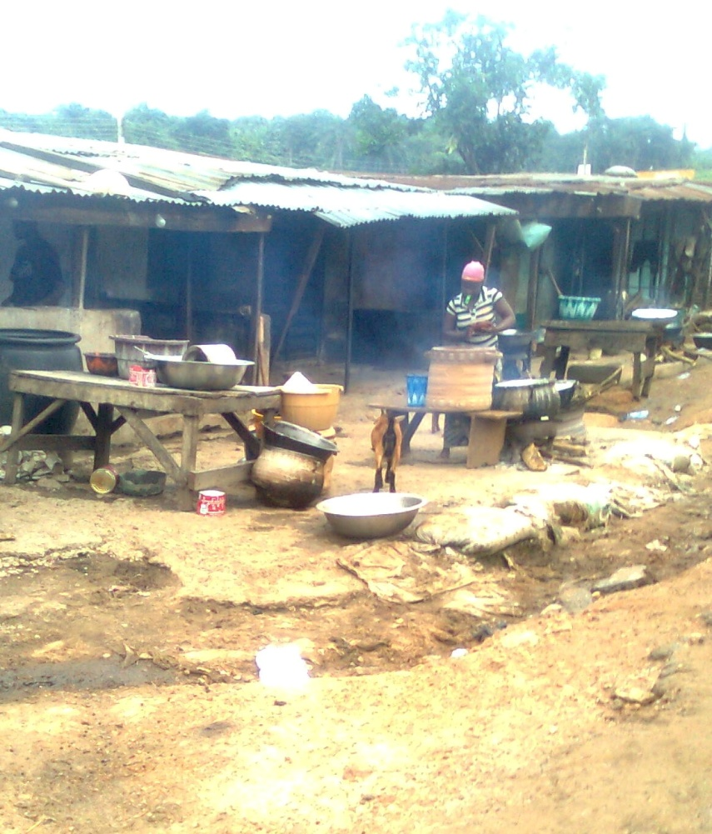

Plate 2: Food Canteen within the market premises
Source: Authors’ Field Survey, 2012
vi. Electricity: The functionality of the market depends on the regular supply of light/power. The market is served by PHCN zonal office at Akinyele. It has its own transformer of 200kv to meet the electricity demand of the market. The major problem is the usual irregular supply which makes its usefulness ineffective.
4.5 Environmental Condition of Lam Adeshina Cattle Market
This section highlights the environmental quality of the market in relation to environmental sanitation, drainage condition, refuse disposal methods and roads condition in the market with a view to determine the attitude of users in maintaining their surrounding environment.
- Poor state of Roads and Refuse disposal system: Findings reveal that drains and roads are filled up with refuse, animal excreta and bones of slaughtered animals. Roads within the market are not fully utilized and even abandoned while refuse disposal system is extremely poor due to lack of well organised collection system. There are four refuse dumps; three within the market and one outside the market. The one directly in front of the market often cause traffic congestion and accident as a result of haphazard dumping. This has made the market to be an eyesore as it becomes stinking with offensive odours. Plate 3 show a typical example of such uncivilized dumping site within the market premises.

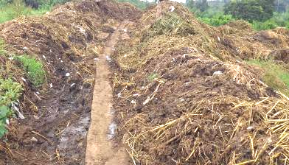

Plate 3: Unorganized refuse dump site around the market premises.
Source: Authors’ Field Survey, 2012
- Poor Drainages System: Parts of the market having drainage facilities are often blocked none in the front of administrative office. The drainage in-front of slaughter slab in the abattoir stand is not functioning; hence, there is no free flow of waste water both at the abattoir stands, beside and in front of cow section as well as beside the motor park. This has made the waste water to pile up in the area thereby breed houseflies within the market area. The abattoir stand is bushy and not well kept to meet the status of a standard market. Without any doubt, this situation can lead to outbreak of fly infested diseases. See plate 4 for a look at the typical condition of abattoir stand in the market.
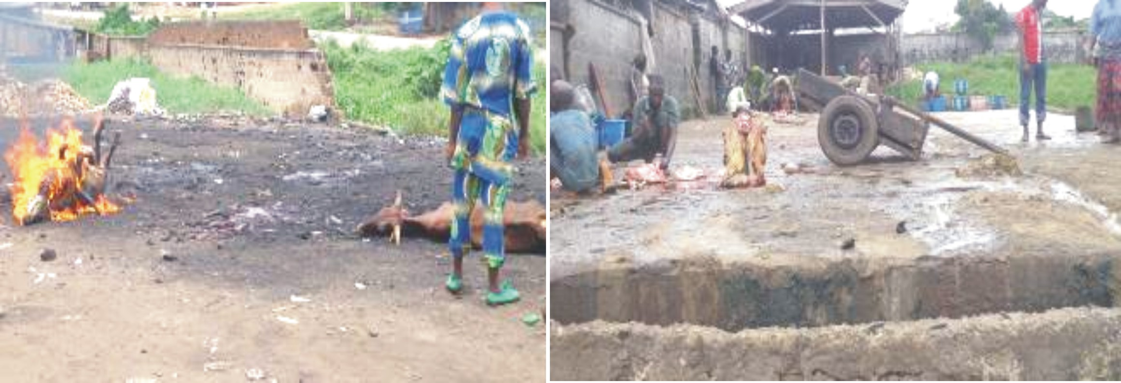
Plate 4: Abattoir stands in the market premises
Source: Authors’ Field Survey, 2012
4.6 Impacts of the Market on Residential Area around the Study Area
The movement of the cattle market to Akinyele has both positive and negative effects on the physical development of adjoining residential area. It can be deduced from Table 4 that 67.44% of the respondents claimed that the market has made positive impact on their area. Such impacts include improvement in socio- economic activities, development of vacant lands and self employment opportunities to young school leavers. Also, it has attracted the movement of non-indigene which has enhanced the commercial and investment activities in the area among others. It was observed from the field that the area was typically rural but the establishment of the market brought several developments, especially the extension of social services like electricity, health centre, among others. Nonetheless, the market has some negative impacts as suggested by 32.56% of the respondents which include increase in cost of land, increase in population which has caused congestion on few available infrastructures as well as increase in traffic hold-ups. The congestion in population has also raised the cost of accommodation rent thereby leading to emergence of sub-standard developments.
Table 4: Impacts of the Market on the adjoining Residential areas
Impacts | Frequency | Percentage
Positive Impacts  Negative Impacts | 29  14 | 67.44  32.56
Total | 43 | 100.00
Source: Authors Field survey, 2012
5.0 RECOMMENDATIONS AND POLICY GUIDELINES
To mitigate problems and inadequacies identified in this study area, it is imperative to put up some preventive measures. The existing problems of shortage of water supply in the market should be given adequate attention. More boreholes should be dug within and around the market area. This is because water is a major component for regular cleaning of the environments, feeding the animals and for fire-fighting purposes. There is need for provision of more refuse receptacles with attached lids which are to be placed at suitable positions within the market for the purpose of effective refuse collection.
The Ibadan Waste Management Authority should be equipped with adequate personnel to carry on the responsibility as frequent as possible, preferably on daily basis. Provision of more public toilets and proper maintenance of existing ones is another sustainable measure to keep the sanitary condition of the market. Those vandalized toilets should be repaired and used as public-paid toilets whereby the proceeds would be used for their upkeep. Provision of separate high voltage transformer is necessary to solve the problem of low current which has characterized the market and adjoining area. Also, there is need for the provision of one fire station with upgraded fire-fighting equipments like fire truck, reservoir, and personnel. This facility should be located near the police station in the market. Akinyele Local Government Authority should be charged with the responsibility of maintaining the public facilities in the market such as refuse receptacles and drainage networks as well as rehabilitation and repair of damaged roads, construction and maintenance of wells.
On the whole, public participation initiative can be employed for the regular upkeep of the sanitary condition of the market as no sanitary proposal could be successful without public participation and cooperation. However, the re-introduction of old sanitary inspectors, locally called ‘wole-wole’ is recommended as a sustainable strategy for any intending improvement effort to be efficiently carried out and sustained in the area. Besides, residents around the area should be educated through enlightenment campaign program whereby they get acquainted with the benefits of healthy environments.
REFERENCES
Anderson, D.J. (2001). Economics of West Africa. Macmillan Education Limited, London
Ezenagu, V.C. (2001). Regional Planning and Development. R and K Publishers, Anambra State, Nigeria.
Filani, M.O. (2005). Transport Market Study – The Bodija Cattle Market in Ibadan. International Review of Social Sciences and Humanities; 2(1):11-32
Northern, R.I. and Haskou, M. (1975). Planning for People Shopping Centres. Journal of Urban and Regional Affairs; 4(2):15-23.
Olakanmi, I.O. (2000). Assessing the Impact of Obada Market on Odo-Oba in Ogo Oluwa Local Government of Oyo State; Unpublished HND Dissertation submitted to the Department of Urban and Regional Planning, Kwara State Polytechnic, Ilorin, Nigeria.
Omole, F.K. (2003). Assessment of the Spatial Distribution of Market Centres in the Development of Osun State. Journal of the Nigeria Institute of Town Planners; XVI (1): 34-41.
Omole, F.K. and Owoeye, J.O. (2007). Inter-Market Transport Situation and Patronage in Osun State, Nigeria. International Journal of Transportation Studies; Federal University of Technology, Akure, Nig; 3(1): 57-67.
Omole, F.K.; Ebo, O; Owoeye, J.O. and Ajayi, M.A. (2012). Analysis of Security Challenges and Environmental Condition in Chikanda Border Market, Nigeria. Urban and Regional Planning Review, University of Lagos; 3(1 & 2):1-8.
Onokerhoraye, A.G. (1976). The Pattern of Housing, Benin, Nigeria. Ekistics, 41(242):125-132
Oshundeyi, T.A (2012). Appraisal of Lam Adesina International Market in Ibadan, Nigeria; Unpublished PGD Dissertation submitted to the Department of Urban and Regional Planning, Federal University of Technology, Akure.

