Parametric CNC Programming For Aluminum Extrusion-moulds
WANG Xingbo BU Jianjun TANG Shuguang
Department of Mechanical Engineering, Foshan University
Foshan City, Guangdong province, 528000
wxbmail@msn.com
Department of Mechanical Engineering, South China University of Technology
guangzhou City, Guangdong province, 510000
bujjsly@126.com
Department of Mechanical Engineering, Foshan University
Foshan City, Guangdong province, 528000
_________________________________________________________________________________
ABSTRACT—The paper first presents a classification of aluminum extrusion-moulds via an analysis of the moulds’ geometric structures and their machining processes. Then the paper puts forward an idea of parametric CNC programming of machining the aluminum extrusion-moulds, and points out some key problems as well as their solutions on instancing the parametric CNC programs in term of the CNC machining processes and the technical behaviors. The paper is of a good reference for CNC programming as the macro packages have obtained excellent effect when applied on Mitsubishi systems and FANUC 0i systems.

Keywords—Mould Machining, Group Technology, CNC programming, macro program
_________________________________________________________________________________

- INTRODUCTION
Group technology (GT) [1], which originated in the 1920s-1930s, mainly reveals the similarity of objects and classifies the objects into a series of groups according to certain regulation of the classification so that objects of the same group are handled by the same method and efficiency of production is improved. In manufacturing industries, GT is a manufacturing technique in which the parts having similarities in Geometry, manufacturing process and/or functions are assembled together. The CNC macro-program [2] is programmed to machining in batch the parts that have similar geometrical structures and machining processes. In recent years, CNC macro programming has been continuously concerned since it is regarded to be an effective way for parametric CNC programming, as stated in [2]-[10]. Since the macro programs are naturally connected with the GT for their ways of handling the similarities of the machining parts, it has a preferable expansibility and valuable probing space to combine the two with each other.
Aluminum extrusion-moulds are the moulds that form aluminum-extruded sections by extrusion processes. The numerous shapes of aluminum-extruded sections require numerous sorts of the aluminum extrusion-moulds. In industrial practice, all the aluminum extrusion-moulds are machined by CNC machining. Considering that many of the aluminum extrusion-moulds have similar geometrical cavities and machining processes, we can first classify the moulds into several classes in each of which every mould shares a single CNC program with the other, and then design a macro CNC program or parametric CNC program for each class, so as to improve the machining efficiency and to reduce the cost of managing the CNC programs.
Foshan area is a primary producing zone of aluminum-extruded sections in China. There are hundreds of producers of aluminum-extruded sections in the area. Thousands of moulds are required to design and machined. It has a very good environment for parametric CNC programming, thus accordingly, we do some work and make some achievements. This paper simple introduce some cases that apply parametric CNC programs for the aluminum extrusion-moulds in Foshan.
- Method of Group Classification for Aluminum Extrusion-moulds
This section introduces the principle and regulation we adopt to classify the aluminum extrusion-moulds. Because the cavities of the moulds are the main machining surfaces, we classify the moulds by both their geometrical shapes and their machining processes. Two moulds that have the similar machining cavities, cutting paths and tool-changing plans are regarded to be in one class. This classification can reduce the number of changing tools and thus can improve machining efficiency. By a large amount of observation, comparison and decision, we choose 60 moulds, which are most typically used in Foshan zone, to be our research objection. The following figure 1 presents portion of the machining surfaces. It can see that there is similarity among these parts. For example, the three parts, (b), (d) and (g), are all grooves of four approximate isosceles triangles.
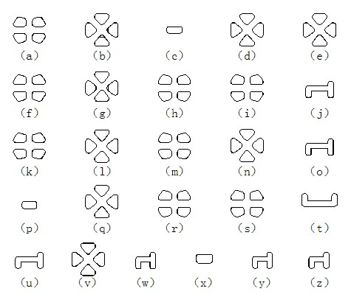
Figure 1: Some of aluminum extrusion-moulds
According to the regulation of GT classification, the 60 moulds are divided into five categories.
The first category includes (a),(f),(h),(i),(k),(m),(r),(s). In these moulds, the cave-surfaces to be machined consist of three line segments and five circular arcs, among which four have the same radius and one is turned an angle of 90 degree, as shown in figure 2.

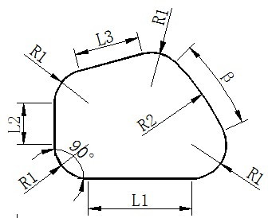
Figure 2: The first category of cave-surface to be machined
The second category includes (b),(d),(e),(g),(l),(n),(q),(v). These moulds all contain a cavity of a triangle with a slope at the top-corner in depth, as illustrated by figure 3. The slope, will vanishes when the length of L1 and L4 is equal, however.

Figure 3: the second category of structure for parts
The third category includes (c),(p),(x).
The fourth category includes (j),(o),(u),(w),(y),(z).
The fifth category includes (t).

3. Parametric CNC Programming Technology
Parametric CNC programming technology for aluminum extrusion-moulds includes a series of key points, such as choice of parameters, plan of the machining paths, use of G90 / G91, location of tool start point, compensation of tool-radius, machining of slope and so on. This section introduces the solutions we choose to set down these problems.

3.1 Choice of Parameters
Parameterization or the macro CNC programming technology uses kinds of variables to replace the machining data of a work piece. The variables will be assigned at the moment a real work piece is being machined. The choice and assignment of the parameters are the first key issue. There are two kinds of parameters for an aluminum extrusion-mould, one is to describe the mould’s geometrical shape, the other is to control the machining progress such as the speed of spindle, the federate, the tool radius, the feed of circulatory machining, and so on. Parameters to describe the shape of the moulds will directly determine the complexity of using and calling the macro programs; they are mandatory to be simple and explicit. Usually, there are many sizes in a cavity; however it is not necessary to parameterize each one because some sizes are related with others. For example, in figure 4, it holds that L6=L2+R, L7=L3=2R,L8=L5+R+L4; therefore, the sizes L6, L7 and L8 can be ignored and be replaced by the other parameters. A reasonable choice is shown in figure 5removed instead of using other parameters to express as shown in figure 5.
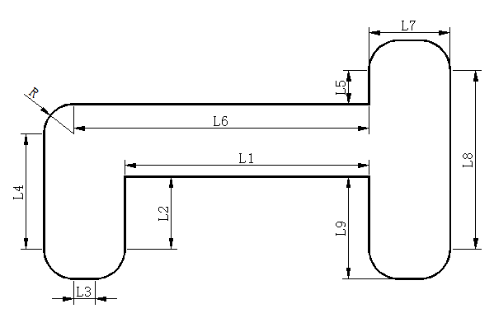
Figure 4: Original sizes of a part
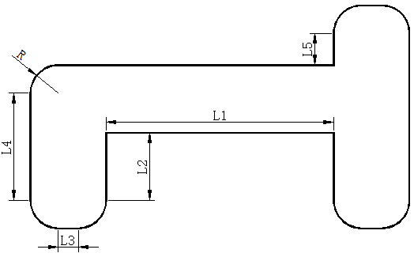
Figure 5: Sizes of reasonable parameters
3.2 Plan of Machining Paths
It is suitable to use a circular cutting mode to mill a cavity of an aluminum extrusion-models. Hence, we choose a middle point to be the start point of the milling path and let it expand gradually to the outer contours, as shown in Figure 6.
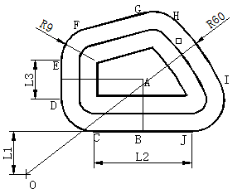
Figure 6: Circular cutting mode with start point at center
3.3 Use of G90 and G91
Most cavities in the aluminum extrusion- moulds are centro-symmetric. Thus, using the incremental mode of G91 can reduce the calculation, improve computing speed of the macro programs. Therefore, we program with G91 incremental mode. Take the figure 7 as an example; suppose the tool be at point A and it federate to point B, it is easier to figure out the coordinates of A to the coordinates of B by using the G91 incremental mode. Also, it is convenient for plan of the tool paths.
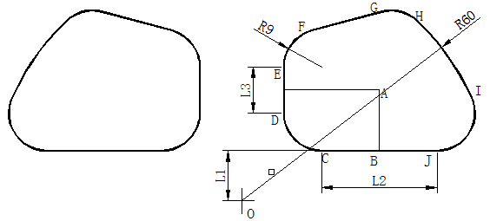
Figure 7: machining method with G91
3.4 Location of Toll Start Point
Theoretically, there are many start points for tool to begin cutting. For example, both A and B can be the tool start points in figure 7. However, it is recommended that a middle point be better because, as stated before, we usually adopt the circular cutting mode. Nevertheless, it requires to say that, the so-called middle point is just a point around the center because it is difficult to calculate an exact ‘center’.

3.5 Tool Down Style
It is known that sunken style and spiral style are two typical styles for CNC milling down to the start point. The sunken style is suitable for the case that a drilling hole is made first while the spiral style is suitable for the other cases. To make our CNC programs suitable for most cases, we adopt the spiral style for larger work pieces so that one tool can finish the whole work on some simple milling machines. The program is described below:
N10 #10=FUP[ABS[#21/#22]]
N20 WHILE [#10 GT 0] DO1
N30 #10=#10-1
N40 G02 Z-[#21/FUP[ABS[#21/#22]]] I[#7]
N50 END1
However, for the small work pieces, e.g., a slot, we adopt the sunken style because there is not enough space for tool to spiral. The program is described below:
N10 #10=FUP[ABS[#21/#22]]
N20 WHILE [#10 GT 0] DO1
N30 #10=#10-1
N40 G01 Z-[#21/FUP[ABS[#21/#22]]]
N50 END1
In the programs above, the # 21 is the machining depth; # 22 is federate; # 10 is the number of federate; # 7 is the tool radius. The program uses the WHILE statement, in which N30 is the decrement of #10 and N40 is the downward federate. The program stops at # 10 vanishes.

3.6 Tool Radius Compensation
Compensation of tool radius is mandatory to reckon on in CNC programming. For milling of the aluminum extrusion-moulds, we do not set a compensation radius because we use the way milling from a middle point to the outer contours and we choose the smallest radius on the contour to be the tool radius. For this action, it requires to calculate an inner offset curve along the outer contour, as shown in figure 8. When programming, we let a separate macro-program calculate the offset curve and let the last tool path be the offset curve.
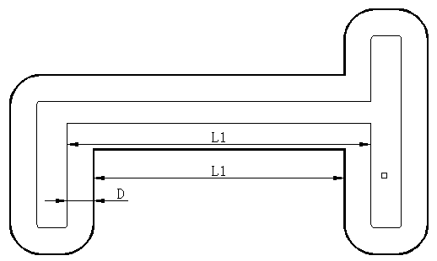
Figure 8: Offset curve along the outer contours
3.7 Milling of Mon-slope Cavity
As stated before, some cavities have a slope surface to be milled and some do have. Typical non-slope cavity is shown by figure 9, where there are four sunken holes with vertical walls. Setting O to be coordinate origin, the four sunken holes are X and Y axle-symmetric. Hence we can only program for one cavity and repeatedly call the program and use the symmetry commands to mill the other three. In practice, we program in the first quadrant and set parameters to be that illustrated in figure 10. In the figure, the point A is the start point at which the milling gradually outward under G91 incremental mode; the down tool style is spiral and the tool path is made by the order B - C - D - G - H - E - F - I – B.
O
Figure 9: Typical non-slope moulds of aluminum extrusion-models
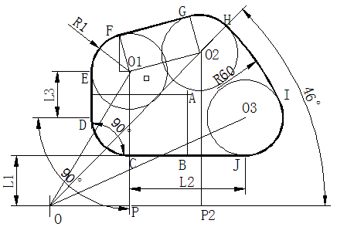
Figure 10: The parameters of a non-slope cavity
3.8 Milling Cavity With a Slope

Some cavities in an aluminum extrusion-mould have a slope surface. A typical structure is shown in figure 11(a), in which the slope occurs at one corner at which the wall of the cavity inclines from the top surface to the bottom. Take one as an example, as shown in figure 11(b).

slope
- A mould with slopes in it
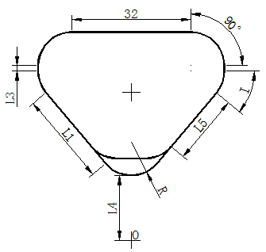
(b) Typical structure of mold cavity with a slope
Figure 11: Mould cavity with slopes
It can see that, the outer contour of the figure is on the top surface and the inner contour is on the bottom. Obviously, the outer contour gradually changes with the depth until it coincides with the inner contour. Let L1 be the length of the outer contour and L5 be that of the inner contour; then L1will become L5 after the change of the contour. At the mean time, the round corner at the outer contour becomes a line segment in the inner contour. Let U be the depth of the cavity, V be the federate down to the bottom and N be the number of Z-axle federates, then it holds
L=L1-（L1-L5）*（M/N
where M is the counter to count the number of Z-axle federates.
And the length of straight line subordinates
L0=2*（L1-L）*COS(I)
where I is shown in the figure 11(b).

4. Simulation and Machining
To ensure machining quality, each macro-program needs simulating by software and experimenting on CNC milling center. The following figure 12 is from the software simulation and figure 13 is from the experiments with a Mitsubishi MP70 milling center, and figure 14 shows actual experiments with the Mitsubishi MP70 milling center. The same work is done by a FANUC i10 milling center. All the experiments show that the parameterization of CNC programs is successful.
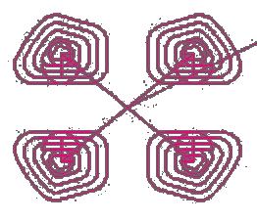
- simulation trajectory without slope in the simulation software

（b）simulation trajectory with a slope in the simulation software
Figure 12: simulation trajectory with a computer

- the debugged trajectory without a slope
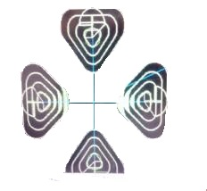
- the debugged trajectory with a slope
Figure 13: debugged trajectory with MP70 for macro program
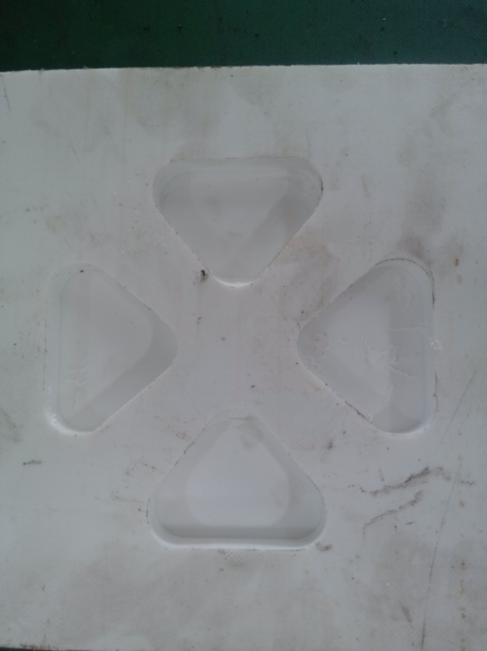
(a) actual machining of picture with the original parameters

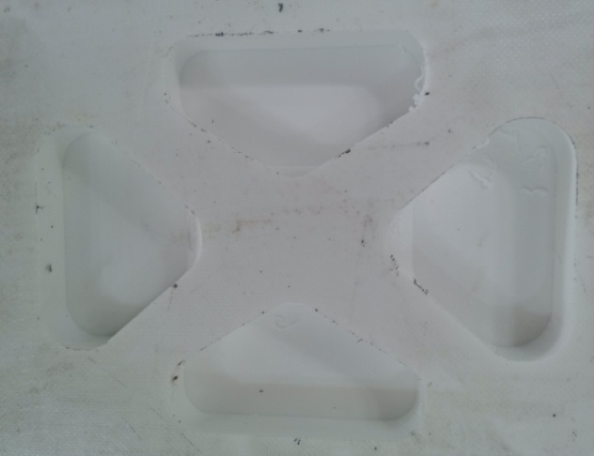
(b) actual machining of picture with the fluctuant parameters
Figure14: the actual machining of pictures

5. Conclusion and Prospection
Parametric CNC programming for aluminum extrusion-moulds based on group technology and macro-program can improve the efficiency of machining and reduce the costs of management. Embedding a certain packages of macro-programs into certain machining centers may provide special service for users who professionally produce aluminum extrusion-moulds and thus can make the CNC equipments some extra values. The application of parametric CNC programming is not only suitable for the manufacturers of aluminum extrusion-moulds, but also suitable for other manufacturing relied on CNC machining. We hope that this article is a useful reference for other people to obtain more valuable applications and to contribute to CNC industries.

6. Acknowledgements
The research work is supported by Department of Guangdong Science and Technology under project 2012B010600018 and 2012B011300068, Foshan Bureau of Science and Technology under projects 2010C012, 2011AA100021 , 2012HC100131, 2013AG10007 and Chancheng government under projects 2011GY006, 2011B1023, 2011A1025, 2011A1030 and 2012B1011. The author sincerely present thanks to them all.

7. References
- Colin Crompton Gallagher, Winston Anthony Knight, Group Technology, Butterworths,1973.
- LI Yian hua,”The exploration and application for macro-program technology in the numerical controlling machining” The journal of Mechanical Design and Manufacture,pp:142-143,2006.
- Yin Bao-zu, "NC Parameter Programming Technology and Its Application", Electro-Mechanical Engineering, Vol.21, No.3, pp 60-64, 2005 (in Chinese).
- LV Xiao min,”The research of quadratic curve NC machining for macro- program”, Hefei University of Technology,2010.
- WU Zing guang, the application of quadric surface milling for macro- program with FANUC Oi system[D], HeFei University of Technology,2010.
- XU Guo quan, CHEN Ya gang, improve machining efficiency with The clever application for macro- program[J],The journal of Mechanotronics,pp:74-75,2011.
- NIE Ying, the application of macro-program for the milling with numerical control programming[J], Enterprise technology development project,pp:4-6,2012.
- LEI Gang, the discusses and application of macro-program with NC programming[J],The journal of Hunan agricultural machinery,pp:50-51,2012.
- S. K. Sinha .Automating Facing Operation On a CNC Machining centre ,International Journal of Engineering Science and Technology,Vol 2, No.12, pp: 7616-7618, 2010.
- Mike Lynch. Parametric Programming for Computer Numerical Control Machine Tools and Touch Probes: CNC's Best-kept Secret. pp:433,1997.
- M Djassemi. A parametric programming technique for efficient CNC machining operations. Computers & industrial engineering. Volume 35, Issues 1–2, pp:33–36, 1998.
- Manocher Djassemi. An Efficient CNC Programming Approach Based on Group Technology. Journal of Manufacturing Systems, Volume 19, Issue 3, January 1, pp: 213-217, 2000.
- Douglas P. Fenster, T. Carrier. …On the direct programming of CNC milling equipment. Computers & Industrial Engineering , Volume 17, Issues 1–4, pp: 252–257, 1989.

