The reliability of the Laffer curve and the treatment of tax fraud
Dimitrios K. Melas
Technical Institute of Central Macedonia,
Magnisias Street, 62124, Serres, Greece

Abstract - In the present study I try to analyze the Laffer curve function, under the prism of OECD and National level. It has been observed that the reduction of the tax rates for a certain period can actually increase the tax revenues collected by companies, but continuing the latter will ultimately lead to their reduction. Moreover, even in times of rising tax rates, in some cases, there is spectacular growth in tax revenue. These observations led us to conclude that on the one hand the theory of Arthur Laffer does not work properly, secondly, that there are many other factors of increased tax revenue from companies that are independent of the level of tax rates.
Keywords : Laffer Curve, Tax Evasion

Introduction
During the 1980s, a decade of large government deficits in the U.S., the theory of Arthur Laffer became the talk of the town. In his theory, Laffer stated that a reduction of tax rates is sufficient to increase the state revenue by reducing evasion of legal entities and the avoidance of companies’ immigration, and more precisely to offshore jurisdictions with minimum tax rates (1996).
The rationale of the curve Laffer is simple and based on two admissible cases whereby a) if the tax rate is zero then the tax revenue would be zero and b) if the tax rate is set at 100%, then the tax revenue again would be zero as no company would be interested in continuing its operations because all the net profits will equal simultaneously with its tax burden.
The above assumptions are reflected in the curve, schematically, as follows:
Income from taxes
Tax Rate %

Based on this curve, the tax rate will be determined at a΄ point where the true state will have sufficient tax revenue, and businesses will have sufficient financial incentives gained in order not to seize its operations (2011). According to Arthur Laffer the reduction of the tax revenue will an increase in the tax rate for entities is that it works as a disincentive to companies that except that increase evasion, also reduce their economic activity. This, according to researchers (2005) applies only to the visible economy, while the shadow economy (informal sector), an increase in the business tax rate leads to an automatic increase of the shadow economy.

The analysis of the Laffer curve at OECD and Greece
Based on the existing macroeconomic data, curves Laffer, both at OECD for the period from 1965 to 2010, and at the level of Greece for the period 1981 to 2008, and are as follows:
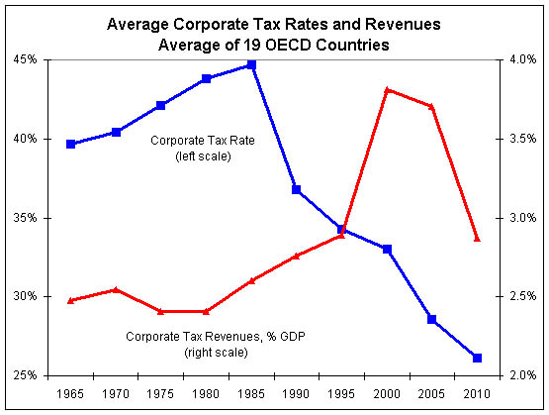
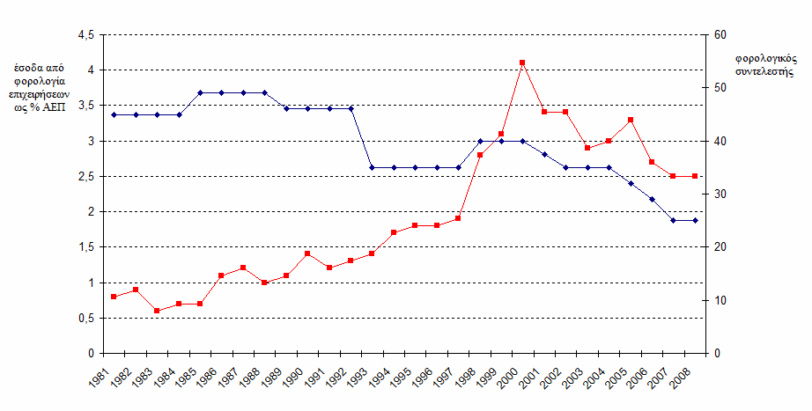
In the figures we present the blue line refers to the change in corporate tax rates, while the red in tax revenue from businesses as a percentage of GDP.
The fact of reducing tax revenue from businesses despite the reduction in tax rates we see it depicted schematically in hand, Member of the OECD from 1998 - 1999 and later, and unlike Greece from about 2002 onwards. This study will try to identify other factors that led to increase or decline in tax revenue in the case of Greece and were independent of the level of tax rates on business profits.

The case of Greece
In the period between 1981 and 2008 income tax rates of companies, revenues from corporate taxes as a percentage of Gross National Product and revenue from corporate taxes as a percentage of total revenue from taxation shall be as follows:
Fiscal  Year | Corporate tax rate | Revenue of corporate taxation as a percentage of GDP | Revenue of corporate taxation as a percentage of total tax revenues
1981 | 45,00% | 0,08% | 0,38%
1982 | 45,00% | 0,09% | 0,38%
1983 | 45,00% | 0,06% | 0,24%
1984 | 45,00% | 0,07% | 0,26%
1985 | 49,00% | 0,07% | 0,27%
1986 | 49,00% | 0,11% | 0,40%
1987 | 49,00% | 0,12% | 0,45%
1988 | 49,00% | 0,10% | 0,41%
1989 | 46,00% | 0,11% | 0,46%
1990 | 46,00% | 0,14% | 0,55%
1991 | 46,00% | 0,12% | 0,46%
1992 | 46,00% | 0,13% | 0,48%
1993 | 35,00% | 0,14% | 0,52%
1994 | 35,00% | 0,17% | 0,60%
1995 | 35,00% | 0,18% | 0,63%
1996 | 35,00% | 0,18% | 0,50%
1997 | 35,00% | 0,19% | 0,62%
1998 | 40,00% | 0,28% | 0,87%
1999 | 40,00% | 0,31% | 0,96%
2000 | 40,00% | 0,41% | 1,21%
2001 | 37,50% | 0,34% | 1,02%
2002 | 35,00% | 0,34% | 1,01%
2003 | 35,00% | 0,29% | 0,91%
2004 | 35,00% | 0,30% | 0,96%
2005 | 32,00% | 0,33% | 1,03%
2006 | 29,00% | 0,27% | 0,85%
2007 | 25,00% | 0,25% | 0,78%
2008 | 25,00% | 0,25% | 0,75%
Average | 40% | 0,19% | 0,64%
Maximum | 49% | 0,41% | 1,21%
Minimum | 25,00% | 0,06% | 0,24%

From the analysis of the above table and the corresponding chart in the previous section, note the following important conclusions:
• Despite the widespread view that distortions are observed only in the Greek tax system, by comparing the Laffer curve both at OECD and Greece we do observe a common pattern, concluding in Greece in 2001 and then where despite the dramatic reduction in tax rates corporate tax revenue is decreasing.
• In the period of very high tax rates (1985 - 1988), we observe that while the tax rate increased by four points compared to previous years (49% of 45%) and tax revenue from the business tax in accordance with the Laffer will had to retreat due to increased tax evasion, increasing from 0.27% of total tax revenue in 1985 to 0.45% in 1987. This course may be due to a more efficient tax administration, either under Ministerial Decision bearing in mind the completion of tax affairs, or simply non-responsiveness of companies with increase tax evasion and avoidance.
• The theory of Laffer applied exemplarily during the years 1988 and 1997 where we have a significant reduction in tax rates, the tax revenue increase respectively.
• In the period between 1998 and 2000, the above theory does not work to a minimum, because while the tax rates rose by five points (40% of 35%), tax revenues continue to grow rapidly. After researching the particular tax period, we can assume that the latter phenomenon is related to the universal reformation of the tax audit mechanism. Obviously, the certainty of the business that will be checked anyway and even by specialized tax assessment is that we forced them to reduce significantly the hitherto performed evasion.
• Between 2001 and 2008, again the theory of Arthur Laffer does not work because although we have lower tax rates, we do have simultaneous reduction in the tax revenues. In conjunction with the similar behavior of the Laffer curve in OECD level, we believe that the global economy has now entered a downward cycle and the increased costs associated with the reduction in the turnover of the undertakings affected the reduction business tax revenue.
• The Laffer curve does not take into account any increase or decrease in the turnover of companies with a simultaneous increase or reduce taxable profits. We believe that Arthur Laffer assumed that the theory applies to periods where the business turnover is constant, a rather ambiguous approach in our days. I believe that the significant reduction in business turnover increases costs due to these fixed costs, resulting in maintaining the same tax rate, the tax revenue is decreasing because of the reduces on taxable profits.
• According to Professor Nick Tatsos (2013), while the tax rate increases and also the tendency is the same for tax-evasion (it increases and benefits fraudsters from tax evasion), it does not happen vice versa. That is, when the tax rate is reduced, the tendency for evasion is not predominant. The reason is simple: when someone learned how to do it and one is addicted to tax evasion, it does not change his behavior easily, even if you reduce the benefits from it. That is, tax evasion will not reduce as the tax rate is reduced.
• Other researchers agree with the behavioral approach according to which the tax rate is considered "fair" (2009) when it gets prices up to 50%. Beyond that point, taxpayers consider the tax rate "unjust", prompting evasion.

The Laffer theory and evasion
If you see it as a total evasion applies inequality:
p * f > g
Where:
p = the probability of discovery of fraud by the Tax Authorities
f = the penalty (financial, administrative, etc., but valued in money)
g = the financial or other benefit from the realization of tax evasion for the tax evader.

It is obvious from the inequality that the smaller the values ​​of p and f the greater the tendency for tax fraud.
In researchers conducted in our earlier writings on the Greek economy and tax evasion, we came to the following conclusions:
• The adoption of governments’ particularly ambitious revenue growth targets, deterrent because from one hand it is impossible to achieve them, on the other hand the latter works as an ‘offense’ to the audit mechanism to push for unachievable targets and consequently to abandon any attempt to improve its performance.
• The penalty itself is unable to act as a deterrent against tax evasion, because chances revelation of reduced dramatically in repeated cases. It is needed the constant evasion be accompanied by strong administrative sanctions (seizure of operations, etc.) 14.
• The increase in the tax rate directly increases the tendency evasion and tax avoidance.
• Increased tax on intermediate goods affects a number of other disciplines, other than that in which affect.
In the present analysis of the tax years from 1998 to 2000 there was a dramatic increase in tax revenues as a share of corporate taxes, I believe that the determinant as to reduce tax evasion is not so much the level of the tax rate, as the probability of conception avoidance. As we mentioned above, this period was completely revised the tax audit mechanism of the country with the establishment of the National Audit Centre, the Regional Audit Centre and Local Audit Centre. On the basis of these data formed the belief in legal entities, which indeed was very much that will be screened in their entirety with tax audit (N.2238/1994) and will not be able to close the tax outstanding or some favorable provision or statue of limitation. In fact there was relevant Ministerial Decision for closing tax cases (number of Directive 1144/1998), but this essentially determined grueling procedures tax audit.
If the above findings try to apply the inequality of tax evasion, then we observe that while the probability of realizing a preventive control tax audit at a rate not exceeding 1% in the case of global tax audit reaches 100%. Substituting figures even:
p = 0,01
f = 5.000 euro (possible total penalty)
Let g = 2.600 euro (10,000 euro earnings x 26% tax rate)
p * f > g replacing 0,01 * 5,000 EUR = 50 EUR < 2.600 EUR and thus the company has a maximum benefit of evasion.
However, if the probability of conception evasion is 100% then the inequality takes p * f > g = 1 * 5,000 EUR = 5,000 EUR > 2,600 EUR and thus verify the inequality, putting off the companies from the tax fraud.
These data are more easily understood if we divide the two branches of inequality with the variables p & f. In the first case we have (p*f)/p > g/p and hence f > g/p which means that someone has an interest to evade taxes when the "penalty" is less than the fraction of the gain from tax evasion to the probability to be revealed. If we replace the instance with the possibility of disclosure avoidance 1% inequality will take values ​​5,000 < (2,600 / 0.01) => 5.000 < 260,000, showing reliefs imbalance between potential costs and benefits of potential tax fraud. Assuming that the probability of disclosure of tax evasion increases to 10%, then the inequality takes the values ​​5.000 < (2,600 / 0.1) => 5,000 < 26,000, and if the probability increased to 60% rates of inequality formed in 5000 > (2,600 / 0.6) => 5,000 > 4,333.
If we now divide both parts of inequality by f we get (p*f) / f > g/f and hence p > g/f. Substituting values ​​again the example in inequality, with probability of disclosure avoidance 1%, it takes the values: 0.01 < 2,600/5.00 => 0.01 < 0.52. Consequently, the left side of inequality should take values ​​greater than 0.52 to be unprofitable evasion and hence the possibility of revelation to exceed 52%.

Conclusions
From the above analysis I consider patently clear that the dominant element in the whole issue of tax evasion is the possibility of revelation and therefore the efficiency of the control mechanism of the country. The reasoned opinion leads us to the following conclusions:
• The inefficiency of the tax audit mechanism of a country leads to high rates of tax evasion regardless of the penalty.
• The same conclusion can be drawn as to the amount of "profit" derived from tax evasion. In case of inefficient operation of the tax audit mechanism the company will evade taxes for minimal "profit". For example when there are preventive tax audit issuing invoices from economic police or by competent crews of the Public Economic Services, the companies will evade taxes even if the items sales have little value and consequently yield little benefit from tax evasion (e.g. sale of bread). In this case, because the companies earn a significant "benefit" of the tax fraud must make continual unlawful acts, multiplied dramatically the probability of arrest. Consequently only a small likelihood of screening prevents it from tax evasion.
• The governments should keep stable institutions of tax audit mechanisms, because retractions in their structure (creation and abolition of tax audit mechanisms), give taxpayers a sense of lack of tax audit and urge them to tax evasion.
• The tax audit structures, even if they cannot make big volume of tax audits, mainly due to lack of staff or lack of expertise in specific economic items, must constantly make their presence felt by creating a sense of impending audit taxpayers.

References
1Yu Hsing. «Estimating the Laffer curve and policy implications». “The Journal of Socio-Economics, Volume 25, Issue 3, 1996, Pages 395 – 401”. The study relied on data from the U.S. between the years 1959 - 1991, determines that the performance of tax revenues on corporate profits is maximized when the tax rate on corporate profits range between 32.67% and 35.21%.
2.The Laffer curve. Wikipedia.org
3. Varoufakis G. & Patokos T. (University of Athens, Department of Economics,) Study on "Taxing businesses through crisis" for the Center for Study and Research of ACCI. Greece Athens, March 2011.
5. W.J.M. Heijman, J.A.C. van Ophem: «Willingness to pay tax: The Laffer curve revisited for 12 OECD countries». The Journal of Socio – Economics, Volume 34, Issue 5, October 2005, Pages 714 - 723
6. OECD 2011
7. Greek Statistic Service 2011
8. Nikos Tatsos is a professor at “Pantio” University of Greece, Athens. The article was published in the "Daily news" newspaper 07.28.2013.
9. Louis Levy, David Masclet, Claude Montmarquette: “A behavioral Laffer curve: Emergence of a social norm of fairness in a real effort experiment» Journal of Economic Psychology, Volume 30, Issue 2, April 2009, Pages 147 – 161.
10.Melas D. “The causes of tax evasion and ways of mitigation" study funded by the Research Committee of the University of Macedonia Salonika Greece
11. D. & K. Melas 'International Tax Planning - Development & Current Developments "page 22. Publications' «Imia» Thessaloniki Greece September 2013
12. D. & K. Melas «The elasticity of taxes and tax evasion. » "Article in the magazine "FOROTECHNIKI APPROACH" in issue No. 204, April 2011

