Optical-electronic measurement of film thickness for the sulphonation of methyl esters in falling film reactors
Luis Diaz¹, Hugo Zea² and Francisco Sanchez³

¹ Department of Chemical and Bimolecular Engineering, Ohio University, Athens (OH), US, ld156509@ohio.edu

² Departamento de Ingeniería Química y Ambiental, Facultad de Ingeniería, Universidad Nacional de Colombia, Carrera 30 # 45-03, Edificio 412, office 201, Bogotá, Colombia.

³ Departamento de Ingeniería Química y Ambiental, Facultad de Ingeniería, Universidad Nacional de Colombia, Carrera 30 # 45-03, Edificio 412, office 201, Bogotá, Colombia.

_________________________________________________________________________________
ABSTRACT— An optical-electronic system for the determination of film thickness in falling film reactor was proposed and applied to the methyl esters sulphonation reaction; calibration and experimental test were performed and a correlation between the film thickness (δ ), measured voltage (V) and the voltage of the empty cell (baseline, V₀) was obtained. Voltage sensing and film thickness calculations were highly dependant on the position of the sensing device respect to the gas feeding point and slightly dependant of the gas flow, under the range of experimental values tested. This optical-electronic system allows a real-time quantitative description of the dynamic behavior of the undulations in the film.

Keywords— Film thickness, Falling film reactors, optical sensors
_________________________________________________________________________________

INTRODUCTION
Falling film reactors (FFR) are equipments widely used in industry; although these devices have been extensively studied there is not a full understanding of their behavior; mainly this is due to the highly dependency of the performance of the FFRs on hydrodynamic factors, which affect transport phenomena within the reactor. Even at low flows and at small Reynolds number values, a liquid going down on a surface under the influence of gravity, either in the presence or absence of a gas flow (parallel or countercurrent), has a random distribution of undulations on the interface. During its descend the film does not develop completely a flat interface. At higher flow rates an unstable transition stage exits just before the flow is fully developed, but as the flow descends the random formation of undulations in the film increases [1-4].
Along with the reaction, heat and mass transfer phenomena on both gas and liquid phases take place; these phenomena become substantially important at the gas-liquid interface. The driving forces for the transfer phenomena and the reaction may change as the process moves along the FFR, either by local changes in the fluids inertia, temperature or concentration. Based on this, it is possible to fully describe the reaction system using continuity and momentum and thermodynamic equilibrium equations. However, the hydrodynamics within the reactor has a profound effect on its performance due to the redistribution effect on the local equilibrium conditions, species concentrations and energy flows caused by the formation and evolution of undulations in the film’s surface [4].
Several authors have tried to study and predict the behavior of these undulations, their effect on the performance of the falling film systems and how they evolved as a function of Reynolds number in each of the phases [5-7]. Experimental results have further confirmed that the appearance of small solitary undulations merge to form larger waves, which carry more matter and transfer more energy and momentum [8, 9]. Some statistical methods have been used to describe the undulation behavior and several methods have been proposed to obtain a dynamic description of the undulations in the film.
In this study, a noninvasive method to measure and evaluate the film thickness in a FFR system has been proposed, this system allows to obtain a qualitative and quantitative description of the phenomena. Methyl esters (ME) sulphonation reaction was used as model reaction test due to its industrial importance in the synthesis of active ingredient in detergent formulations. The results were analyzed for statistical description methods where the average film thickness is taken as the value of the mean of the data obtained.

EXPERIMENTAL
- Materials and equipments
Film thickness distribution tests were performed in a falling film glass reactor of 1.27 cm diameter and 75 cm of length. A scheme of the sulphonation set up is presented in figure 1. The flow of air and methyl esters were selected based on the formation of a homogeneous film wetting the inner wall of the FFR [10, 11]. To measure film thickness, infrared (IR) optical sensors were used. The optical sensors consisted of infrared light-emitting diode (LED) and a photo sensor. The emitting LED and the photo transistor were coupled in a resistor network and a power supply connected in series circuit, ensuring that the LED maintains a constant light emitting and the photo transistor is operating in its linear region. The film reactor is fitted with three sets of optical sensors located at a distance of 10, 35 and 60 cm from the inlet of the ME into the reactor; in order to facilitate the description and analysis of the experiments and results the photo sensor will be denominates S1, S2 and S3 for the distances 10, 35 and 60 cm, respectively. Signals form the transistor receiver is digitized allowing capturing data in real time, with 53 ms of average sampling. Signals from the digitizer were gather on a computer using MATLABTM.

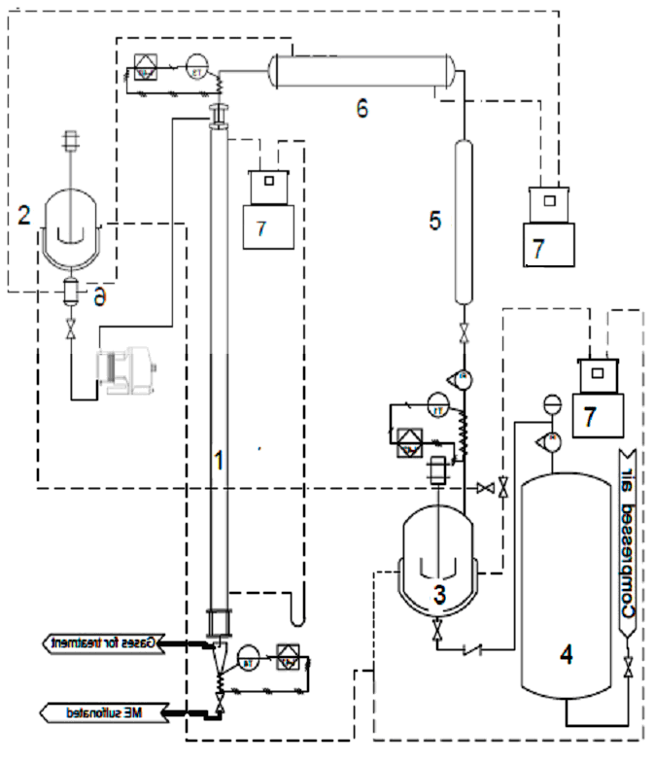
Figure 1: Sulphonation reaction system. 1) falling film reactor, 2) ME loading tank, 3) Oleum loading tank, 4) (H₂SO₄ concentrated) column, 5) demister, 6) heat exchangers, 7) thermostatic bath. Solid lines represent process lines, and dashed lines represent heating and cooling lines.
- Experimental Procedure
Based on previous studies published elsewhere [10] is possible to establish the experimental ME and flow gas conditions where a proper thin film developed in the reactor wall; these conditions are summarized in Table 1. For the distribution of film thicknesses determination the reaction system was preheated to the suitable reaction temperature as reported by Torres [12] and Castaneda-Rivas [13], 50 ºC to 40 ºC for the gas stream and the metal ester, respectively.

Table 1: Experimental conditions for ME sulphonation and hydrodynamic analysis.
Test | ME Flow (g/min) | Air Flow (L/min) | Molar ratio SO₃/ME
A | 3.72 | 41.78 | 1.51
B | 4.76 | 41.78 | 1.21
C | 5.00 | 41.78 | 1.12
D | 8.14 | 64.82 | 1.54
E | 10.79 | 64.82 | 1.20
F | 11.43 | 64.82 | 1.12

The FFR was loaded with ME according to the values summarized in Table 1 and then to the gas flow was adjusted. To measure the film thickness voltage signal is collected, digitized and transmitted to a computer using a serial port. A total of 200 data points were simultaneously taken by each sensor for all tests presented in Table 1. The total sampling time for each sensor was 10.63 seconds, which provides an average measurement time of 53 milliseconds. This time was defined based on those reported by Xu et al. [14], who reported that the shorter step time of a undulation is in the order of 60 ms.

- Photo sensor calibration

In order to determinate the film thickness based on the voltage response in photo sensors, a series of calibration experiments were performed; those experiments consisted in 6 test cells of various deepness in which films of different thickness can be created, each cell was place in between the LED emitter and the photo sensor system as shown in Figure 1. The photosensors were polarized by a power supply-resistance system that allows to modify the input voltage; the photo sensor transistor receiver generates a signal proportional to the amount of collected light, obtaining as a final result a voltage signal for each thickness measured; the data was used to obtained an equation that correlates the film thickness as a function of the measured voltage.
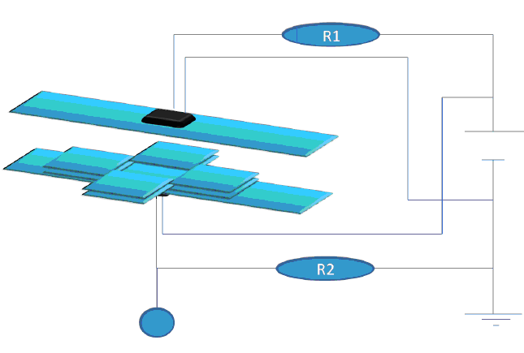
Figure 2: Photo sensor cell’s calibration system representation.

Experimental conditions and results of the photo sensor calibration experiments are presented in Table 2

Table 2: Experimental conditions and results of the photo sensor calibration.
Induce potential | 4.41 V |  | 4.53 V |  | 4.54 V |  | 4.59 V
Thickness (mm) | Empty | Full | Empty | Full | Empty | Full | Empty | Full
0 | 3.79 | 3.79 | 3.86 | 3.86 | 3.88 | 3.88 | 4.11 | 4.11
0.15 | 3.79 | 4.03 | 3.86 | 4.10 | 3.88 | 4.12 | 4.11 | 4.35
0.3 | 3.79 | 4.06 | 3.86 | 4.12 | 3.88 | 4.14 | 4.11 | 4.38
0.5 | 3.79 | 4.09 | 3.86 | 4.13 | 3.88 | 4.15 | 4.11 | 4.40
0.65 | 3.79 | 4.10 | 3.86 | 4.15 | 3.88 | 4.18 | 4.11 | 4.41
0.8 | 3.79 | 4.11 | 3.86 | 4.17 | 3.88 | 4.21 | 4.11 | 4.44
1 | 3.79 | 4.15 | 3.86 | 4.21 | 3.88 | 4.22 | 4.11 | 4.46

The data presented in Table 2 is use to find a correlation of the dependent variable (film thickness) and the independent variable (voltage); data were analyzed by means of STATGRAPHICS CenturionTM, using the logistic regression model maximum probability mapping available for multivariable systems. Equation 1 shows the correlation obtained for the film thickness (δ) depending on the measured voltage (V) and the voltage of the empty cell (baseline, V₀); V₀ is the value of voltage obtained when there was not film created in the calibration cell.

$δ=\frac{e^{η}}{1+e^{η}}$

Where η is expressed by equation 2

$η=−\text{172}\text{.}\text{573}+\text{42}\text{.}\text{2865}∗V−2\text{.}\text{2884}∗V_{0}$

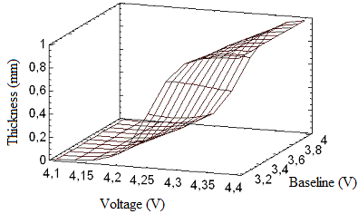
Figure 3: Surface response of δ as function of V and V₀.

A setting response surface is presented in Figure 3. The experimental results showed that the signal generate by the photo sensor increases as the film gets thicker increases, the signal emitted by the photo sensors , and if the light received by the collector is greater as the film thickness increases. It was observed that in either case the voltage signal reaches the value of the induced potential, which may indicate that the presence of a small layer of liquid between the glass plates, facilitates the passage of light through them and the photo sensors have adequate sensitivity to perform the measurement of film thickness in the reactor.
3. RESULTS AND DISCUSSION
During the experiments to determinate the film thickness in a FFR system, the first experiment performed was a test in which no liquid flow gas set up and only the was gas flows were fed into the reactor, these tests were done with the purposed of simulate the situation in which no film has formed (zero thickness); the voltage signal measured for these tests present not significant changes in the experimental values or in the statistical parameters. The result obtained for the experiments for film thickness equal zero (no ME flow) with and without the presence of gas flow are reported in Table 3; it is important to highlight that these experiment shown that the voltage measurements are not affected by the gas flow in the reactor and provide a single line for each sensor.
Table 3: Zero film thickness experiments data
 | Sensor 1 (S1) | Sensor 2 (S2) | Sensor 3 (S3)
Position (cm) | 10 | 35 | 60
Minimum voltage (V) | 3.0231 | 4.1137 | 4.2901
Maximum voltage (V) | 3.0642 | 4.1536 | 4.3583
Average voltage (V) | 3.0437 | 4.1336 | 4.331
Standard deviation | 0.01186 | 0.01152 | 0.01278
Variance coefficient | 0.00239 | 0.00279 | 0.00295
SNR | 256.4 | 35.4 | 338.9
Once the photo sensor have been calibrated and the zero thickness film measurements have been performed, it is possible to do the tests for the determination of the film thickness on a FFR operating under the conditions summarized in Table 1 in order to perform such tests it is assumed that the film formed during the experiments is homogeneous in the radial direction. Therefore along the perimeter of the reactor, at any length, the film thickness will be the same.
Representative results of the film thickness determinate from voltage signal measured in the photo sensors (S1, S2 and S3) as function of time for experiments A and F are presented in Figure 4 and Figure 5; film thickness determinate from experimental data for experiments A, B, C, D, E and F are summarized in Table 4.

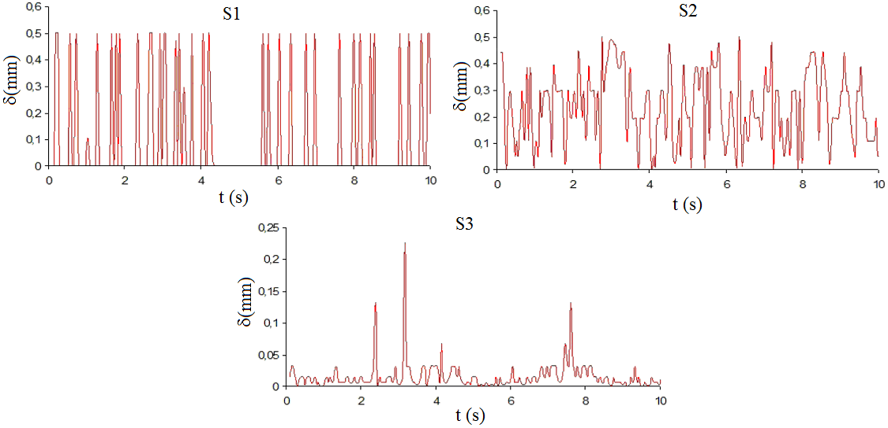
Figure 4: Film thickness measured at S1, S2 and S3 for test A.

The results obtained shown the effect of gas entering the reactor which is reflected in the wide oscillation in the voltage values measured in S1, photo sensor that is located next to the gas entering point, as observed in Table 4. It is also noticeable from the data presented in Table 4 the evolution of the film thickness along the reactor length as well as the reduction of voltage oscillation, due to the stabilization of the film and the reduction of undulations along the film; the film hydrodynamic is highly affected by the gas inlet, as the dispersion of the measurements of the sensor S1 for all trials is very high. This behavior turns out to be a characteristic of the system studied, where the gas enters the reactor, measured voltage reported by S1 reflects the highly unstable hydrodynamic condition of the gas; on the contrary S3 is the sensor that lies away from the gas inlet section therefore it can be considered that at this point the hydrodynamic of both gas flow and liquid flow have completely developed, implying that a less affected measurement of thickness value will be located at S3.
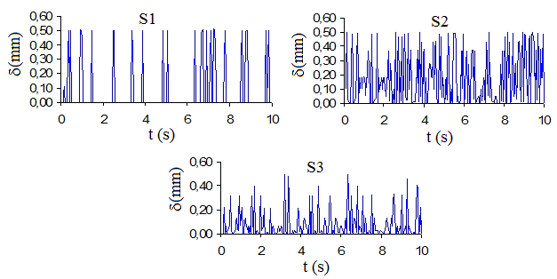
Figure 5: Film thickness measured at S1, S2 and S3 for test F.
However it is possible to see how the film is affected by the gas inlet, as the dispersion of the measurements of the sensor S1 for all trials is very high. This behavior turns out to be a characteristic of the system studied, where the gas enters the reactor, measured voltage reported by S1 reflects the highly unstable hydrodynamic condition of the gas; on the contrary S3 is the sensor that lies away from the gas inlet section therefore it can be considered that at this point the hydrodynamic of both gas flow and liquid flow have completely developed, implying that a proper measurement of thickness value will be located at S3.
Table 4: Summary of film thickness.
Test A (3.72 g/min ME; 41.78 L/min air)
 | Sensor 1 (S1) | Sensor 2 (S2) | Sensor 3 (S3)
Position (cm) | 10 | 35 | 60
Average thickness (mm) | 0.094 | 0.023 | 0.015
Maximum thickness (mm) | 0.5 | 0.5 | 0.23
Minimum thickness (mm) | 0 | 0 | 0
Test B (4.76 g/min ME; 41.78 L/min air)
Position (cm) | 10 | 35 | 60
Average thickness (mm) | 0.066 | 0.048 | 0.045
Maximum thickness (mm) | 0.5 | 0.083 | 0.12
Minimum thickness (mm) | 0 | 0.01 | 0
Test C (5.00 g/min ME; 41.78 L/min air)
Position (cm) | 10 | 35 | 60
Average thickness (mm) | 0.12 | 0.079 | 0.050
Maximum thickness (mm) | 0.5 | 0.17 | 0.12
Minimum thickness (mm) | 0 | 0.02 | 0
Test D (8.14 g/min ME; 64.82 L/min air)
Position (cm) | 10 | 35 | 60
Average thickness (mm) | 0.05 | 0.069 | 0.024
Maximum thickness (mm) | 0.5 | 0.5 | 0.3
Minimum thickness (mm) | 0 | 0 | 0
Test E (10.79 g/min ME; 64.82 L/min air)
Position (cm) | 10 | 35 | 60
Average thickness (mm) | 0.15 | 0.13 | 0.048
Maximum thickness (mm) | 0.5 | 0.44 | 0.21
Minimum thickness (mm) | 0 | 0.011 | 0
Test F (11.43 g/min ME; 64.82 L/min air)
Position (cm) | 10 | 35 | 60
Average thickness (mm) | 0.063 | 0.17 | 0.077
Maximum thickness (mm) | 0.5 | 0.5 | 0.5
Minimum thickness (mm) | 0 | 0 | 0
From Table 4 it can be observed that as the induced voltage increases, the response value is also higher. Taking data from the highest average for the sensor S1 in each of the assay is obtained that the average thickness at the reactor inlet is 0.5 mm, these results are in agreement with those obtained by Zhang, Wang, & Peng [8, 9].
The experimental thickness values obtained allow comparing with the values predicted by mathematical model proposed in literature; although no specific model has been reported for the methyl esters (ME) sulphonation, Gutierrez et al. [15] have proposed a model for alkyl benzenes sulphonation in a FFR; the mean error between the experimental result obtained and the predicted by the model oscillates in the range of 9 to 54%, depending in the reaction condition used in the mathematical model.

CONCLUSIONS
Experimental determination of film thickness in falling film reactor was performed using a LED emitter photo sensor system; calibration and reaction test were performed and correlated obtaining a statistical correlation between the film thickness (δ), measured voltage (V) and the voltage of the empty cell (baseline, V₀). Voltage sensing and film thickness calculations were highly dependant on the position of the sensing device respect to the gas feeding point and slightly dependant of the gas flow, under the range of experimental values tested. This optical-electronic system allows a real-time quantitative description of the dynamic behavior of the undulations in the film.

AcknowledgEment
The authors express their gratitude to Universidad Nacional de Colombia for the financial support through the DIB project number 8830

References
1. Telles, A.S. and A.E. Dukler, Statistical Characteristics of Thin, Vertical, Wavy, Liquid Films. Industrial & Engineering Chemistry Fundamentals, 1970. 9(3): p. 412-&.
2. Chu, K.J. and A.E. Dukler, Statistical Characteristics of Thin, Wavy Films .2. Studies of Substrate and Its Wave Structure. Aiche Journal, 1974. 20(4): p. 695-706.
3. Chu, K.J. and A.E. Dukler, Statistical Characteristics of Thin, Wavy Films .3. Structure of Large Waves and Their Resistance to Gas-Flow. Aiche Journal, 1975. 21(3): p. 583-593.
4. Killion, J.D. and S. Garimella, A critical review of models of coupled heat and mass transfer in falling-film absorption. International Journal of Refrigeration-Revue Internationale Du Froid, 2001. 24(8): p. 755-797.
5. Karimi, G. and M. Kawaji, Flow characteristics and circulatory motion in wavy falling films with and without counter-current gas flow. International Journal of Multiphase Flow, 1999. 25(6-7): p. 1305-1319.
6. Kil, S.H., S.S. Kim, and S.K. Lee, Wave characteristics of falling liquid film on a vertical circular tube. International Journal of Refrigeration-Revue Internationale Du Froid, 2001. 24(6): p. 500-509.
7. Talens-Alesson, F.I., The effect of superficial gas velocity on wavy films and its use in enhancing the performance of falling film reactors. Chemical Engineering & Technology, 2000. 23(7): p. 629-632.
8. Zhang, J.T., X.F. Peng, and G.P. Peterson, Experimental investigation on the hydrodynamics of falling liquid film flow by nonlinear description procedure. International Journal of Heat and Mass Transfer, 2000. 43(20): p. 3847-3852.
9. Zhang, J.T., B.X. Wang, and X.F. Peng, Falling liquid film thickness measurement by an optical-electronic method. Review of Scientific Instruments, 2000. 71(4): p. 1883-1886.
10. Diaz, L., H. Zea, and F. Sanchez, Hydrodynamic Effects Asociated to Methyl Ester Sulphonation in Falling Film Reactors. Dyna-Colombia, 2013. 80(178): p. 44-50.
11. Stein, W. and H. Baumann, Alpha-Sulfonated Fatty-Acids and Esters - Manufacturing Process, Properties, and Applications. Journal of the American Oil Chemists Society, 1975. 52(9): p. 323-329.
12. Torres, J., Producción de alfa sulfo-estearato de metilo en un reactor de película descendente, PhD Thesis, Universidad Nacional de Colombia, Bogotá, Colombia. 2009.
13. Castaneda, W. and A. Rivas, Dimensionamiento de un sistema para la sulfonación de ésteres metılicos del aceite de palma a nivel laboratorio. Universidad Nacional de Colombia, Bogotá. 2004
14. Xu, Z.F., B.C. Khoo, and N.E. Wijeysundera, Mass transfer across the falling film: Simulations and experiments. Chemical Engineering Science, 2008. 63(9): p. 2559-2575.
15. Gutierrez, J., C. Mansteixido, and J. Costalopez, Improved Mathematical-Model for a Falling Film Sulfonation Reactor. Industrial & Engineering Chemistry Research, 1988. 27(9): p. 1701-1707.

