**SUPLEMENTARY**

**CASE DATA**

Table 1. Examination Result of The Demolition Victims

|  |  |  |  |  |  |  |
| --- | --- | --- | --- | --- | --- | --- |
| **No** | **Name** | **Age (years)** | **Symptoms** | **Physical Examination** | **Otoscopy** | **Audiometry** |
| 1. | RR (PAD 2)  Prada 31160045770695 | 19 | * Hearing loss * Tinnitus | Face excoriation | Bilateral tympanic membrane perforation | Mixed type hearing loss moderate-severe |
| 2. | IS (PAD 2)  Praka 31090643230889 | 28 | * Hearing loss * Tinnitus | Face excoriation | Sinistra tympanic membrane perforation | Acoustic trauma |
| 3. | FR (PAD 2)  Prada 31170020750798 | 19 | * Hearing loss * Tinnitus | Face excoriation | Tympanic membrane intact, hyperaemia +/+ | Acoustic trauma |
| 4. | RH (PAD 2)  Pratu 31120043160890 | 27 | * Hearing loss * Tinnitus | Face excoriation | Sinistra tympanic membrane perforation | Acoustic trauma |
| 5. | RP (PAD 2)  Praka 31090638040588 | 29 | * Hearing loss * Tinnitus | Face excoriation | Sinistra tympanic membrane perforation | Acoustic trauma |
| 6. | Lgt (PAD 4)  Prada 31150031410995 | 22 | * Hearing loss * Tinnitus | Face excoriation | Tympanic membrane intact, hyperaemia +/+ | Acoustic trauma |
| 7. | Rmj (PAD 4)  Pratu 31110340171191 | 25 | * Hearing loss * Tinnitus | Face excoriation | Dextra tympanic membrane perforation | Acoustic trauma |
| 8. | NH (PAD 4)  Prada 31160373461194 | 22 | * Hearing loss * Tinnitus | Face excoriation | Dextra tympanic membrane perforation | Acoustic trauma |
| 9. | Isw (PAD 4)  Praka 31060543190486 | 31 | * Hearing loss * Tinnitus | Face excoriation | Tympanic membrane intact, hyperaemia +/+ | Acoustic trauma |
| 10. | Mds (PAD 4)  Pratu 31120040840590 | 27 | * Hearing loss * Tinnitus | Face excoriation | Tympanic membrane intact, hyperaemia +/+ | Acoustic trauma |
| 11. | YP (PAD 4)  Serda 21140098771095 | 21 | * Hearing loss * Tinnitus | Face excoriation | Bilateral tympanic membrane perforation | Mixed type hearing loss moderate-severe |
| 12. | BP (PAD 10)  Prada 31150355230496 | 21 | * Hearing loss * Tinnitus | Face excoriation | Tympanic membrane intact, hyperaemia +/+ | Acoustic trauma |
| 13. | Ssr (PAD 10)  Serda 21150201130295 | 22 | * Hearing loss * Tinnitus | Face excoriation | Sinistra tympanic membrane perforation | Acoustic trauma |
| 14. | Rzk (PAD 10)  Prada 31150031330995 | 22 | * Hearing loss * Tinnitus | Face excoriation | Tympanic membrane intact, hyperaemia +/+ | Acoustic trauma |
| 15. | AK (PAD 10)  Sertu 21120007201291 | 25 | * Hearing loss * Tinnitus | Face excoriation | Bilateral tympanic membrane perforation | Acoustic trauma |
| 16. | RF (PAD 10)  Sertu 21120221790692 | 25 | * Hearing loss * Tinnitus | Face excoriation | Dextra tympanic membrane perforation | Acoustic trauma |

Physical examination data shows that all of the soldiers (100%) suffered tinnitus, hearing loss, and face excoriation due to grenade explosion during the demolition training. Ten soldiers (62,5%) suffered tympanic membrane rupture, either unilateral or bilateral, and almost all of the soldiers (87,5%) suffered acoustic trauma.

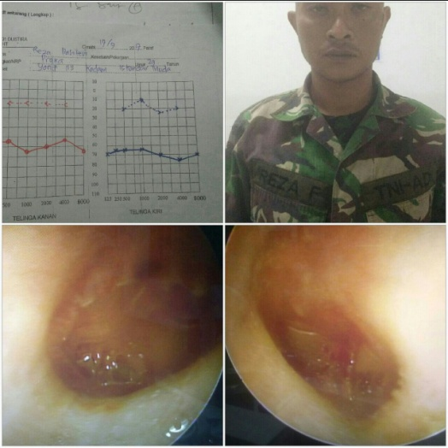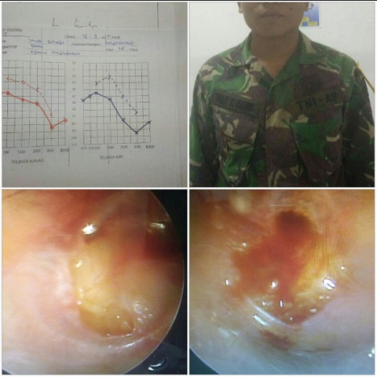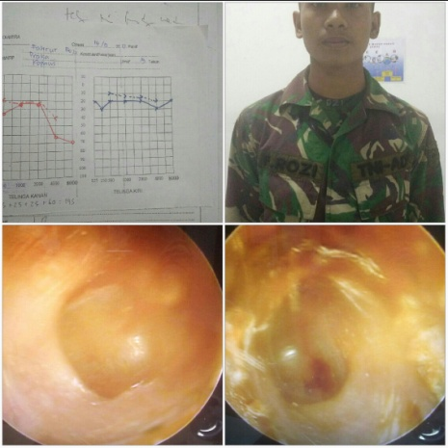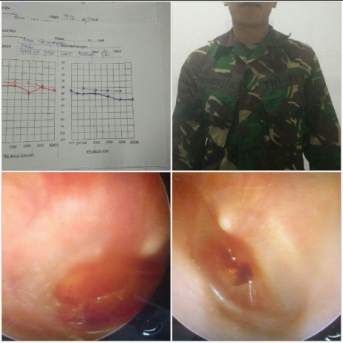 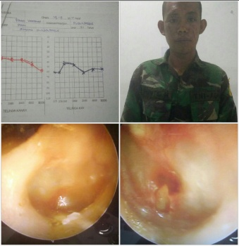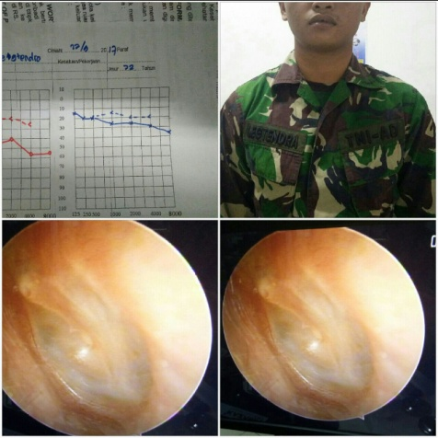 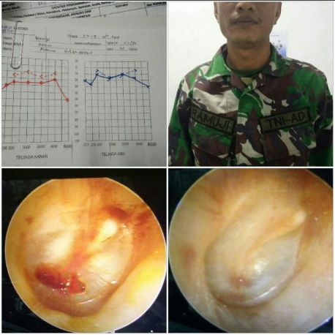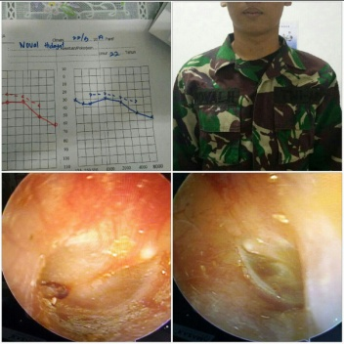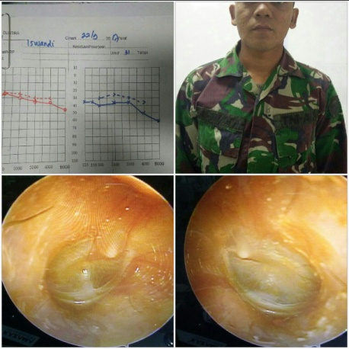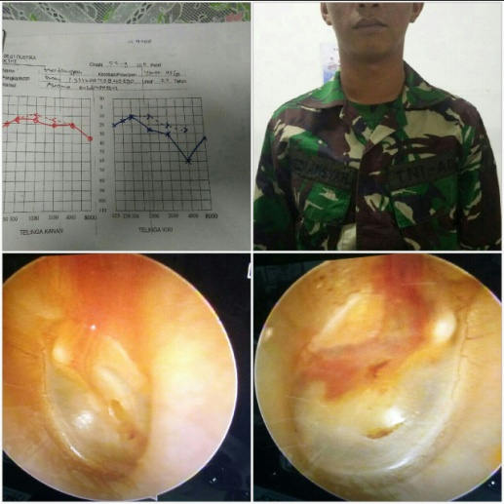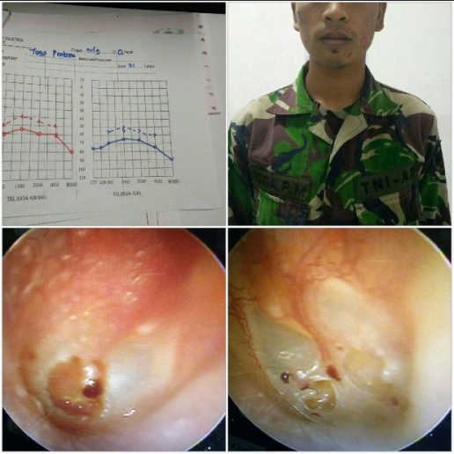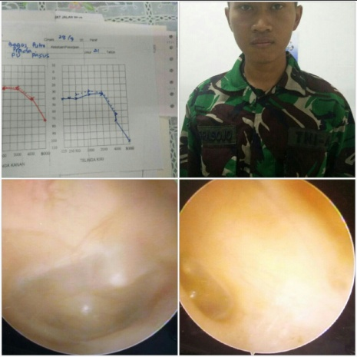

12

11

10

9

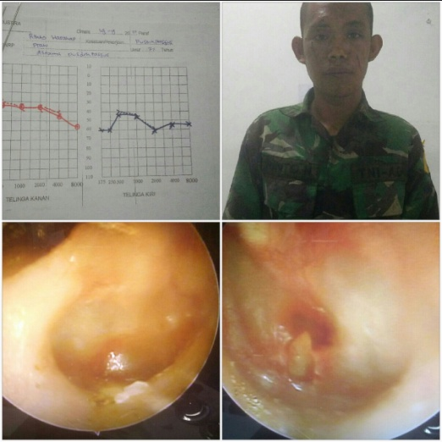5

77

21

67

21

4

3

8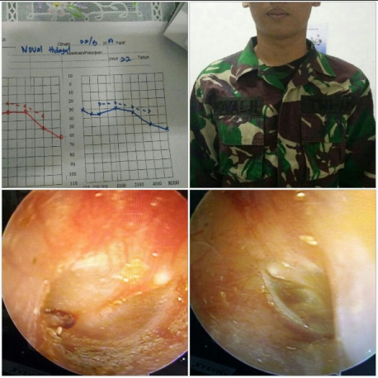7

21

2

11

21

21

21

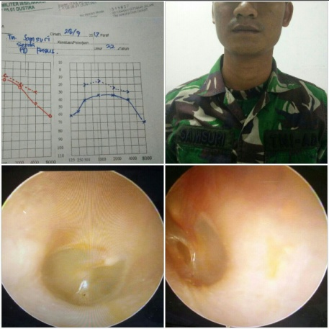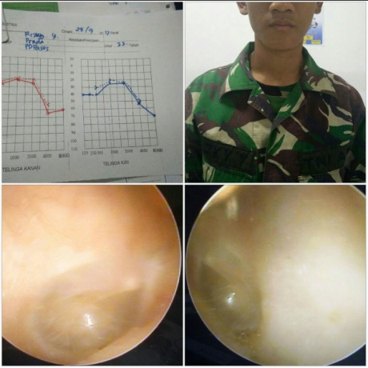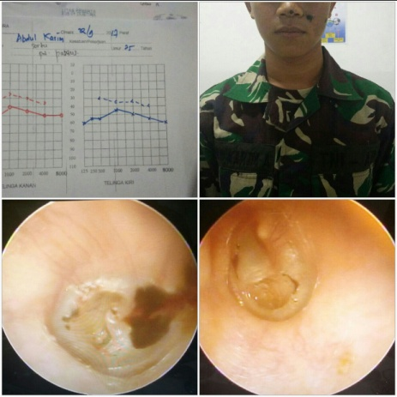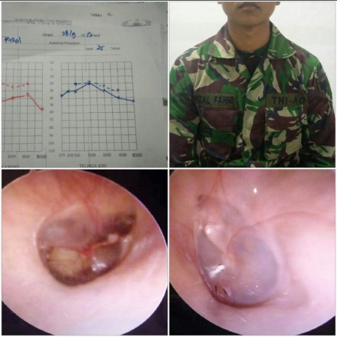

16

15

14

13

Figure 1. Otoscopy and Audiometric