The Profile of Pandanaran Street Texture Semarang

Edy Darmawan,1*, Agung Dwiyanto2, Adhisti Samsinar Enis3

1, 2, 3Architecture Department, Engineering Faculty, Diponegoro University, Semarang, Jawa Tengah, Indonesia

*Corresponding author’s email: edy_darmawan@yahoo.com

ABSTRACT---- Souvenirs Center Pandanaran located between Simpang Lima and Tugu Muda Semarang is the main street of the city experienced many problems, among other issues a very limited car parking space. Of the types of public service facilities have characteristics with human activities vary. Besides the activities of different relationships, so that will give advantage profile shapes are different too. Research conducted qualitative methods will be utilized by the scope of the Simpang Lima as the first node and the second Tugu Muda. Among them will be investigated buildings along the street profile and will be known texture type along the street between Simpang Lima and Tugu Muda. Pandanaran Street Corridor space structures are included in a single block which is situated as part of a street line and a closed circulation system including linear. Homogeneous texture patterns, because there is only one pattern arrangement, the arrangement of buildings mass form a linear pattern. The presence of buildings that support these activities should be directed to become more orderly so as to create the regularity of the buildings mass and the urban space that can provide mutual harmony in Pandanaran Street Corridor. One of them can be done by adjusting the height and distance of the buildings.

Keywords ; Profile, Texture, Pandanaran Street, Semarang City.

1. INTRODUCTION

The city as one of human life expression that very complex [10]. The city growth dynamic way, because life of the people have close relation one at each other. The city as the human expression of the city, that’s why the district of the city have influence the life of place [10]. The district of the city have situation that not convenience, that will be make the community in the district feel not comfortable in the area. Therefore, the district of the city need emphazise of many element that related between activities of the people and the place.

The city consists of the physical that have function to accommodate the people comfortability. The shape of physically have a spatially of area and relation to each other between urban spatial one and each other, it to be unity. Linkages between places of the city needed the network of the street that related between spatial city and design of space of the buildings [8]. The harmony of composition of physically, its has to emphasized for environment and situation comfortability.

The street is part of the physically of the city [3]. The corridor of the street is the part of the city that related the elements that related life and human activities. The street corridor now as identify an area, because it easy to known by pedestrian. The imaging of a district depend on the image of the street performance. The characteristic of physic performance at the street will be create the identities area and influenced by good visual qualities [2]. But the reality, the city tend growth organic way follow the developing of community and community activities with unconcept of clear planning. Physical reality of the city considered of human activities, finally often to plan without planning.

The facilities of the city should become one of the guide of build a district of a good city, usually people and government only need the functional for growing the economical aspect without consideration with the environment. The appearing the pretentious buildings without care the environment and the area around the city is not suitable for communities and feel not comfortable in the place. It is happened in around of Pandanaran Street Corridor Semarang.

Pandanaran Street Corridor is unique corridor street that different of another street in Semarang. It because Pandanaran Street that related two important point between Simpang Lima and Tugu Muda. Simpang Lima area as central business district for Semarang City, while Tugu Muda area as a center of culture (historical area) for Semarang City. Surrounding of Tugu Muda consists of Lawang Sewu buildings as heritage buildings of Netherland Government and also Tugu Muda monument that the memory of Semarang five days war. The two areas that different characteristic related by linier of Pandanaran Street Corridor. In the beginning of area Pandanaran Street Corridor known as elite housing area in the place there are elite housing. But, the developing of Simpang Lima to be a central business district and separated of treading Johar area until Tugu Muda is to be Pandanaran Street growing repeatly [9].

At the area of Pandanaran Street begin appear any kind of commercial buildings as like offices, hotel, supermarket, hospital, banks, gift shop, and restaurant. Slowly, the function of Pandanaran Street area at the beginning as housing now change become make use buildings, that consist of not only housing but also the activities of trading and business. Appearance the commercial buildings at the Pandanaran Street area especially gift shops to make the area a lot of visitor of community from city and the out of town of Semarang. Gifts shop make Pandanaran Street begin to known center of souvenirs. Knowing the unique and characteristic of area Pandanaran Street, it the said the street is potential for Semarang. Therefore, at the report of research will be interest to performance the profile and texture of Pandanaran Street in Semarang City.

2. RESEARCH METHODOLOGY

The research method is basically a way to get data with a specific purpose and usefulness [5]. Into this report, methodology used is descriptive qualitative. Implying the methodology qualitative descriptive as a method used to describe and outline the findings in the field that aims to collect information in actual and detail, identify problem, making comparisons or evaluation, and determine what anybody else is doing in the face of the same problem and learn from experience them to set the decision in time to come [1]. The use of the methodology qualitative descriptive in this report used to get an overview of spatial pattern in Pandanaran Street and outline the findings in the field in actual and detail in the form of object in a field made in the form sketches shots and photos. Types of research methods will be implemented are included in the survey were used to obtain data from a particular place in nature (not artificial), but the researchers did treatment in data collection. For example, by distributing questionnaires, structured interviews, and observation [5].

The research location is in Pandanaran Street Corridor is which included Central Semarang District and part of BWK I Semarang. This area had function as central public services, where in there was office activities, trade, recreation, housing with high density, and conservation historic buildings. Administrative boundaries of Pandanaran Street is Brigadir D.I. Panjaitan Street in North, Simpang Lima in East, M.H. Thamrin Street and Kampung Subuh Street in South, and Tugu Muda in West. To simplify and focus the research in view of the type activity and buildings function that dominates in Pandanaran Street Corridor, the street is divided into three segments as seen in the picture below.

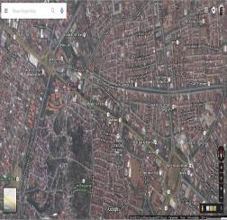
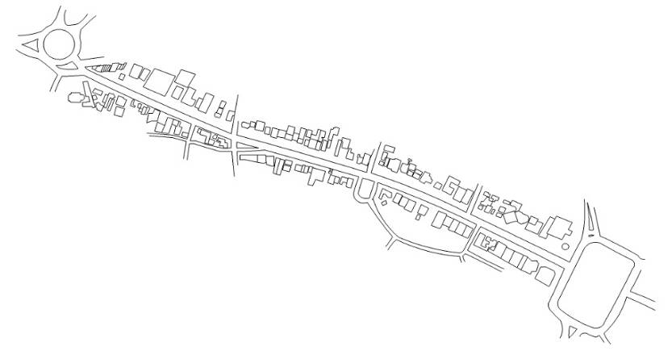
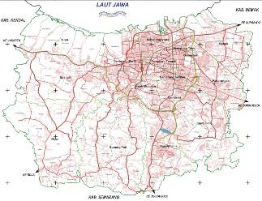
3
2
1

3
2
1

Fig. 1: Research Location Pandanaran Street Corridor.

2
3
This research aims to get an overview of the buildings texture on the Pandanaran Street. For this aims our research strategy using the survey method. The first step in our research is identify physical condition and activities that occur. This step is taken to determine physical condition and buildings function in the Pandanaran Street Corridor. For this, researchers conducted direct observations in the field and supported by documentation to reinforce the data obtained from the observation. The second step is look the shape and mass of buildings along Pandanaran Street Corridor. Data obtained through literature study and field observations.

The results of the data collection and analyzed by qualitative descriptive analysis techniques incorporating photos or pictures and tables as supporting information. Data analysis is the process of systematically searching for and compiling data obatained from interview, fields notes, and other materials that can be easily understood and its findings can be communicated to others [6]. Activity in the data analysis is based on classifying data based on variables and types of respondents, tabulate the data based on the variables of all respondents, presenting the data of each variable studied, perform calculations after that drawing conclusions from what has been done.

3. RESULTS AND DISCUSSIONS

Based on the result of survey in the field note that Pandanaran Street Corridor experience rapid growth along with development of Semarang City. It can be seen from the function of the existing buildings along Pandanaran Street Corridor, which used to function as an elite residential area into a regional mix. On the right side of the street looks different forms of buildings with commercial functions can be seen at this figure below.

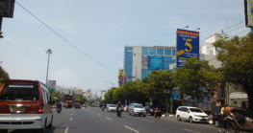
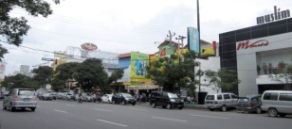

Fig. 2: Buildings along Pandanaran Street Corridor.

Pandanaran Street Corridor is a secondary arterial street with two lanes or two directions with a width of 7 meters. Two way traffic flow in Pandanaran Street starting from the east and west by streetblock in the form of street marking. This street is impassable for the vehicle up to 3 cars in one lane. In some streets, especially in shopping areas, parking lots for 4 wheel vehicles that are on the right side of the street with parallel parking system one layer on the street. Pandanaran Street Corridor is also equipped with a drainage channel on the right side of the street. Channels are located on the north street, uppers using the cover of a functioning paving for pedestrian pathways, while the channel is in the south of the street left open. In addition, there are also procurement trees along Pandanaran Street that serves as greening and shade for passerby, although not all take off the street can be overgrown trees because of parking expansion of buildings units.

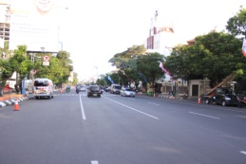
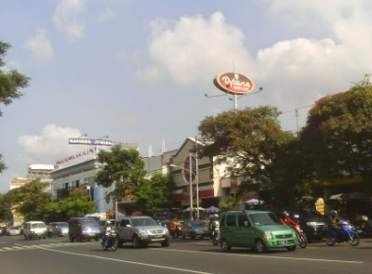
Fig. 3: Trees along Pandanaran Street Corridor for Greening.

Pandanaran Street Corridor is a linear area that extends along 1,3 km. Physical form Pandanaran Street Corridor of a series mass buildings and pedestrian ways. In a pattern of Pandanaran Street Corridor who follow street network usually found various activities who are scattered throughout the right left side corridor street. Pedestrian ways that is having wide 1,5 – 2 m and high about 15 – 20 cm as seen in picture below (Fig. 4). Element in the form of pedestrian ways consisting of paving arranged forming an angle 45º and coinciding between each paving. Paving is developed elongated follow asphalts streets, any part of the side of bordering asphalt streets bounded by cement stone as a barrier and on its inside bounded by pavement arranged resembling collapsed wall height of about 50 cm or restricted by a parapet buildings parcels proper bordering pedestrian ways. Pedestrian ways who is on the right left side of the Pandanaran Street are equipped with a crossing that its position transverse to the highway and is present in several segments of the street.

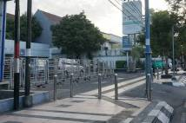
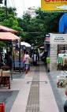

Fig. 4: Pedestrian Ways in Pandanaran Street Corridor.

The use of a space in Pandanaran Street Corridor consisting of function trade and service are scattered throughout street and housing function that are in the presence of north and south the street. Buildings shops and lodging to control and change function occupancy at the east end of the relatively close to the Simpang Lima area as a direction orientation, while in part the west end of the it is oriented for Tugu Muda, buildings with function occupancy controlled and turned them into buildings trade and services. At the end of Pandanaran Street there are transition function buildings of worship facilities, namely mosque and church. Direct observation found in the field, known that the buildings trade and services 60%, a mixture of 20%, housing 15%, and offices 5%. From these data it can be seen if the activities that took place in Pandanaran Street Corridor is dominated by trading activities and services, followed by other activities such as housing activities, office activities, and many more. In addition, there are also Car Free Day (CFD) activity which is common every weekend. CFD in Pandanaran Street started from a Merbabu Bookstore to Simpang Lima from morning until 09.30 WIB. Residents who came in CFD not only from Semarang City, but also from the area around Semarang City as Ungaran, Kendal, Demak, and Salatiga. Most People even ride on public transportation with his family the arrived at the CFD for exercise, either walking or cycling relaxed. Even, there are also people who come to the area CFD just to enjoy a variety of merchandise sold in the area. The use of space in Pandanaran Street Corridor will be described in detail through in the figure below.

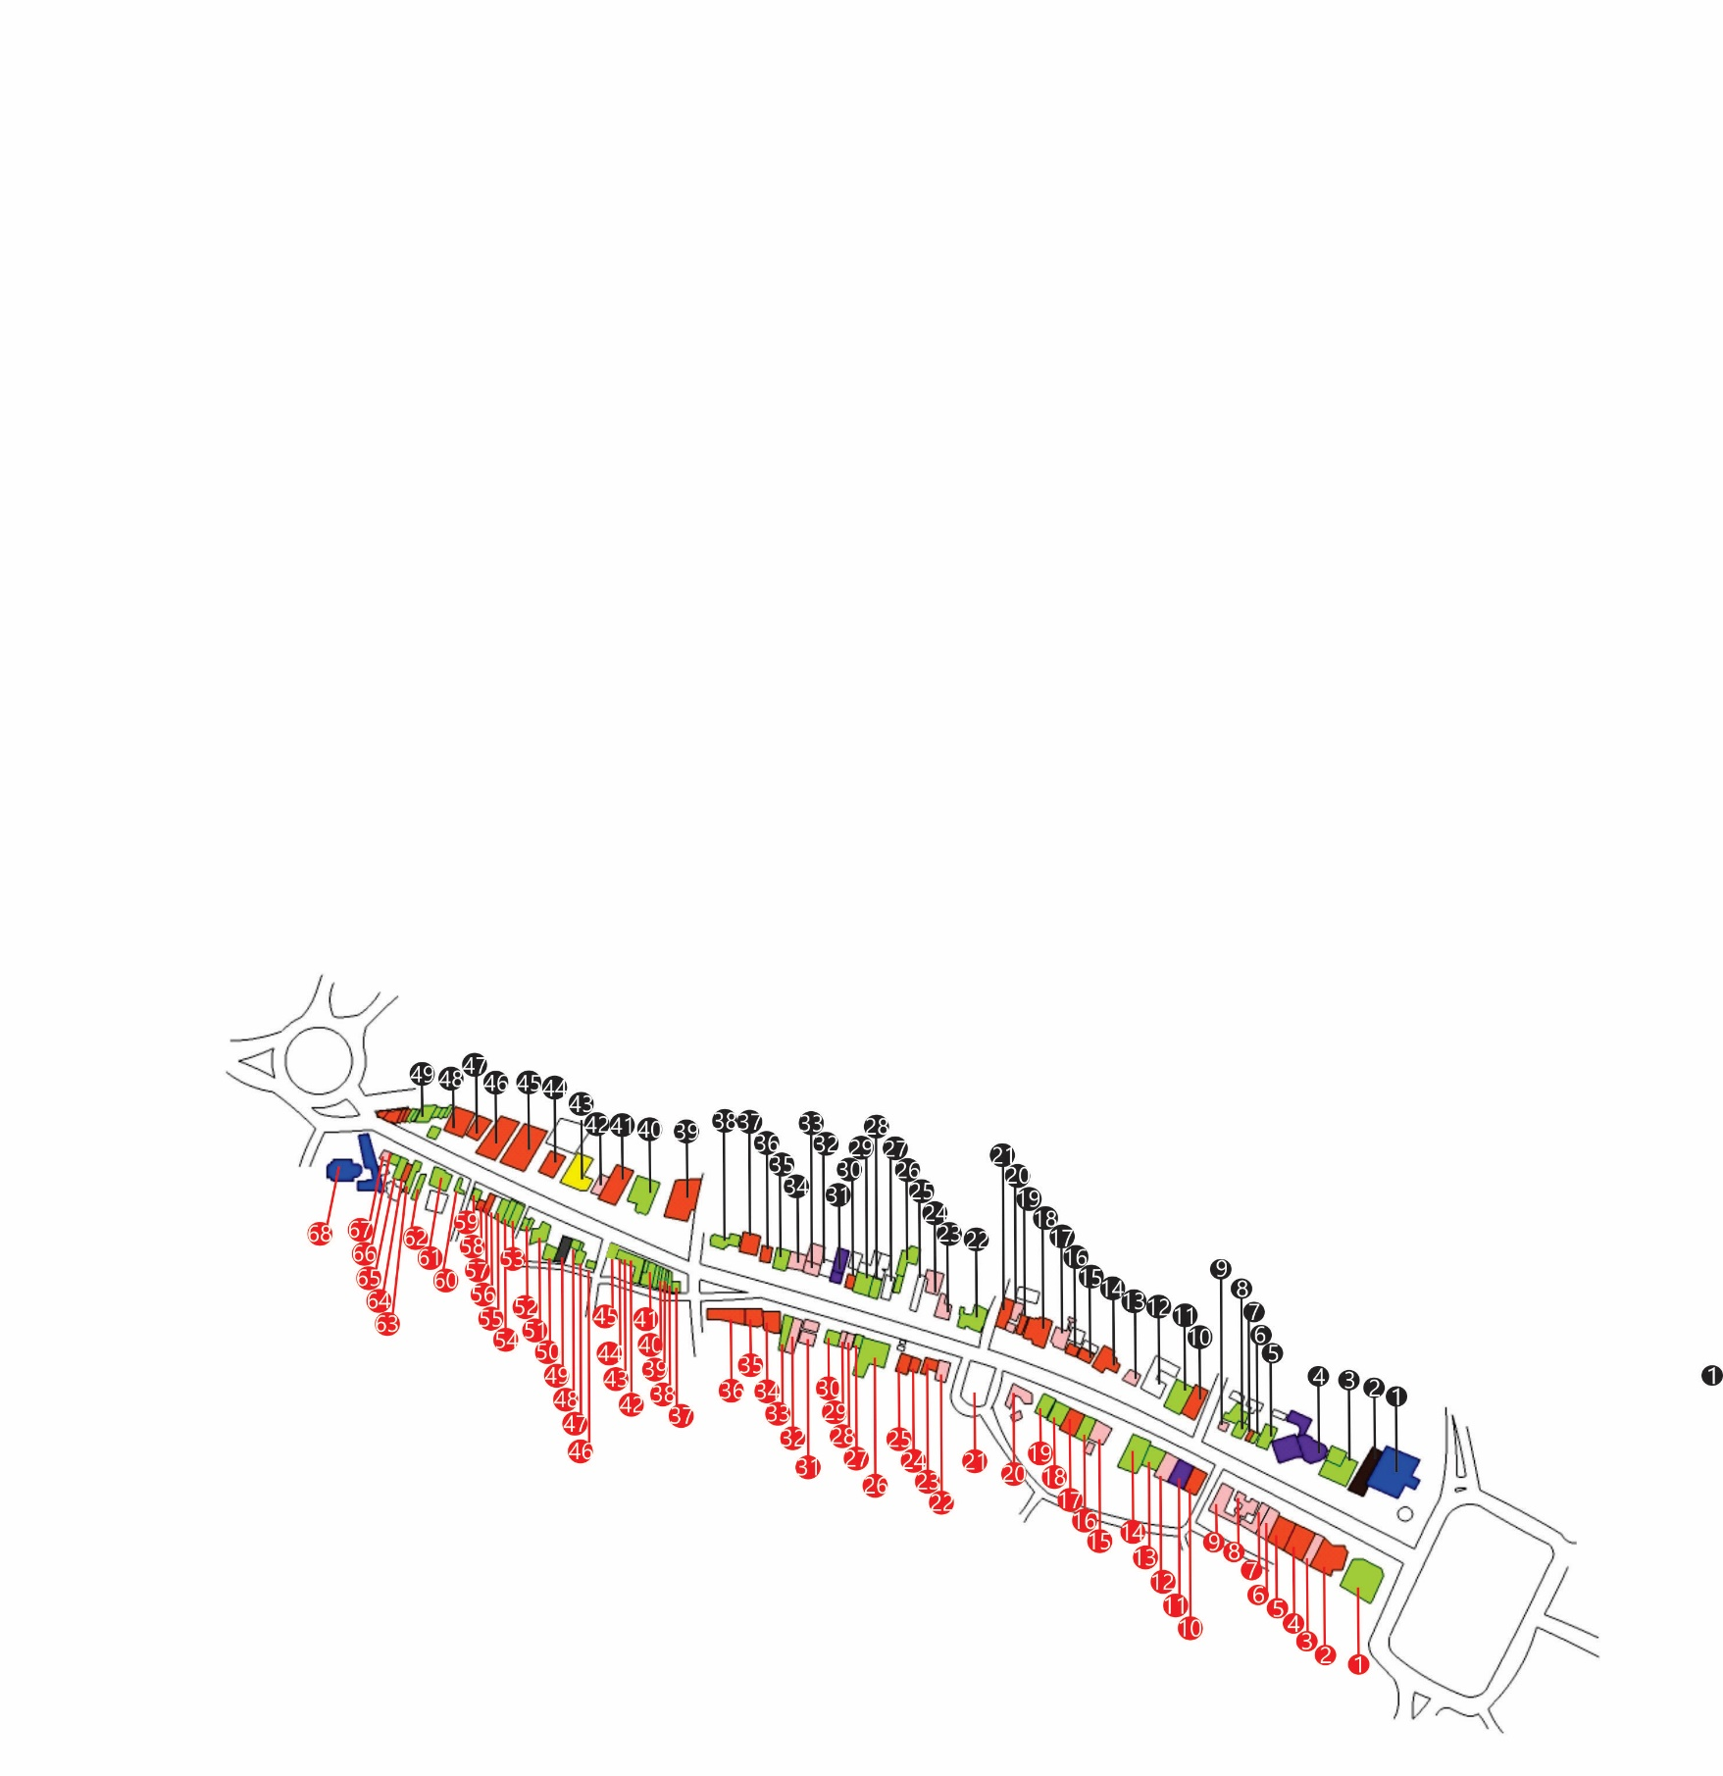
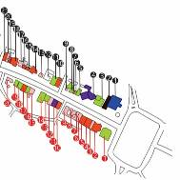
SEGMENT 3
SEGMENT 2
SEGMENT 1
Pandanaran Street Divided Into 3 Parts
3
2
1
INFORMATION:
Offices

Empty Buildings

Hospital

Parking Buildings

House

Hotel

Trading

Religious Buildings

Fig. 5: The Use of Space in Pandanaran Street Corridor.

Segment 3 of Pandanaran Street located near Simpang Lima. Buildings in this area dominated with souvenirs stores that has 2 floors and need large parking area.

In segment 2, still domination with offices, but this buildings covered with bank and office which has 2 floors and need parking area for customer.
Actually, buildings in the Pandanaran Street segment 1 still domination with commerce buildings.

Northeast Side
Southwest Side

Fig. 6: Buildings Function Every Segment in Pandanaran Street Corridor.

Location of Pandanaran Street that linking Simpang Lima area as the CBD and Tugu Muda area as a cultural center would provide a strong character when viewed using linkage theory, because both places are part of the city that became center of activity for Semarang City. Physically, the existence of Tugu Muda be made as symbol of to commemorate the historical event occurring in Semarang City, while area Simpang Lima there is the Pancasila Field who around it there are trading activities and services. High diversity of existing buildings in Pandanaran Street Corridor give the impression of different space in some take off street, because the distance different buildings. Neverthless, overall Pandanaran Street Corridor give the impression of comfortable, familiar, and not creepy.

Visually, Pandanaran Street Corridor is a visual linkage with the pattern of the corridor, where the most powerful visual linkage occurs in segment 3. In this area there are buildings shops that sell typical food Semarang City, so well known as a souvenirs center of Semarang. Characters Pandanaran Street area as a center of Souvenirs Semarang formed through the integration of community activity that occurs in the region with a container (space) to perform these activities.

For structural linkage comprised of additional, connections, and copy elements [8] was not seen in Pandanaran Street Corridor, because the street is solid and leaves no empty land to add buildings. A physical buildings is located along an Pandanaran Street is the process of changes in landuse from their land settlement who developed into buildings dominated for the activity of trade and services. This condition have an impact on additional buildings vertically then influential to variation high place and mass buildings pattern also a pattern that there is movement. Pandanaran Street visible only as a link between two nodes namely Tugu Muda and Simpang Lima with neutral patterns, so not too much feel like linkage structural. At node Simpang Lima, physical form Baiturrahman Mosque buildings is coordinator for the region. This can be seen from the shape of the roof of mosque which was adopted by Hotel Santika as seen in the picture below.

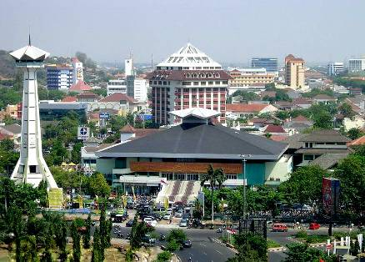

Fig. 7: Hotel Santika Adopted Roof of The Baiturrahman Mosque.

A city has a number of unit that has meaning, so needed additional way for consider directly [10]. In this case needs linkage collective to group buildings having a same characteristic. Pandanaran Street Corridor is one area fused and do not stand alone, but mass buildings pattern in this area not forming composition between a mass buildings and open space a dynamic and rhythmical. A buildings form that also not having similarities of structure collectively. When viewed from linkage collective, pattern Pandanaran Street Corridor that shape linear straight can be said to approaching element megaform. This is because Pandanaran Street Corridor is part of urban area is not so obvious from the form or trademark.

Various types of activities in Pandanaran Street Corridor would affect the use of space and shape of the buildings, to which it will give effect to the structure of space on this street corridor. Moreover, Pandanaran Street Corridor is strategic location linking Simpang Lima Area that serves as Central Business District (CBD) and Tugu Muda Area that serves as a cultural center would also have an impact on the structure space. Space structured analyzed using figure ground theory seen by the element of solid and void, where the Pandanaran Street Corridor void element is visible on the street and solid element seen in the mass buildings on the side of Pandanaran Street Corridor includes singles block located as part of the street and circulation lines including linear closed system. Pattern texture is homogeneous, because there is only one pattern arrangement, the arrangement of mass buildings that form linear patterns (lined up on the right left side of the street).

In segment 1 it can be seen that the form of figure ground is homogeneous and form a pattern corridor and clarify the existence of node Simpang Lima as CBD. Element solid at Pandanaran Street Corridor segment 1 demonstrated buildings function to banking activities, shops, and buildings a place of worship such as mosque. To elements void shown through the existence of open space, where its existence less not so strong. In this location there is one city park functioning just not only as a room green city, but also to facilitate community activities and as a recreation site for community. In addition, the existence of open space to segment 1 Pandanaran Street Corridor also serves as a water absorption that can reduce the potential for flood. An open space is in segment 1 Pandanaran Street is active and passive. An overview of pattern figure ground in segment 1 Pandanaran Street is presented in figure below.

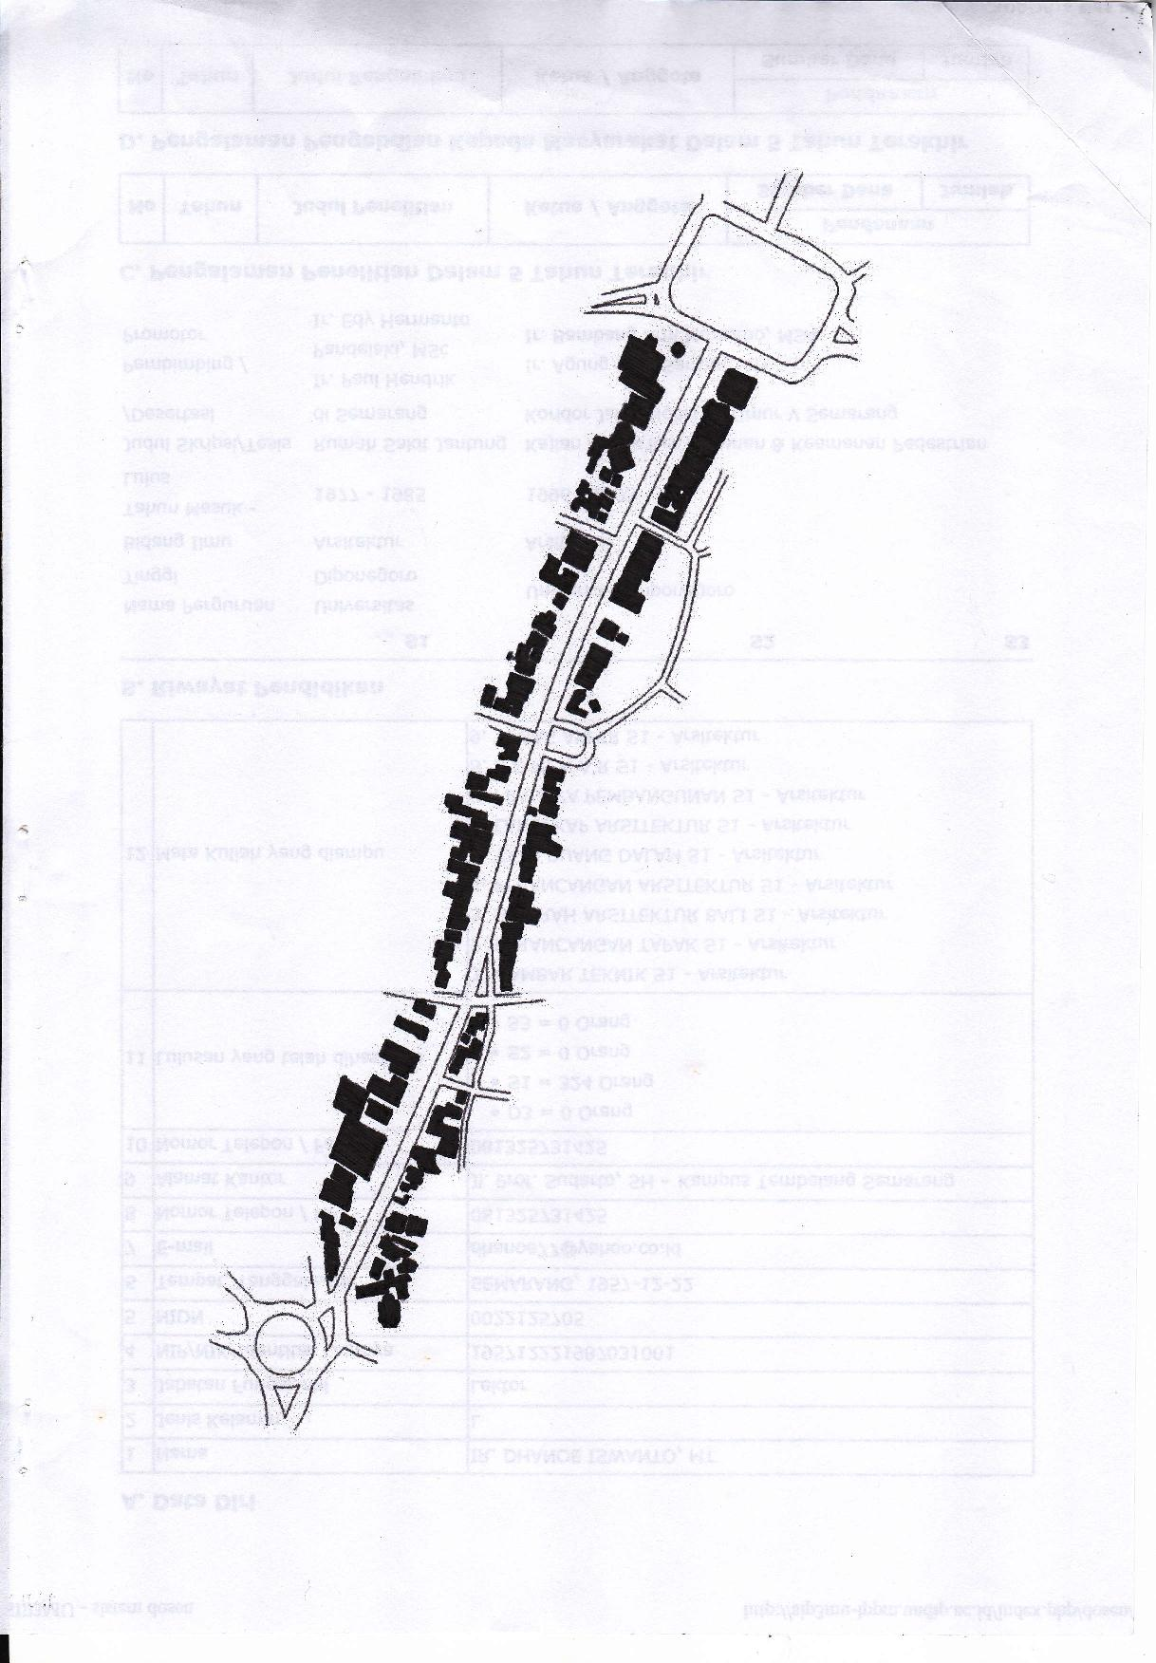
SEGMENT 1
Southwest Side
Northeast Side

Fig. 8: Figure Ground in Segment 1 Pandanaran Street Corridor.

Segment 2 from Pandanaran Street Corridor are still got influence from Simpang Lima as CBD, to make shape figure ground in segment 2 also is homogeneous from a pattern corridor as in segment 1. Although equally got the influence of Simpang Lima, but elements soid in segment 2 more dominated by building with function to hotel and shops. While the form of figure ground in segment 3 tended to be heterogeneous because of node historic characterized by the existence of the Lawang Sewu Buildings, complex Cathedral, Museum Mandala Bhakti, and Governor Official Residence Central Java. Elements void of open space in segment 2 and 3 not so invisible because the height of varying, a buildings form is not uniform, and dimension buildings relatively wide. As for pattern figure ground in segment 2 and 3 Pandanaran Street is presented in figure below.
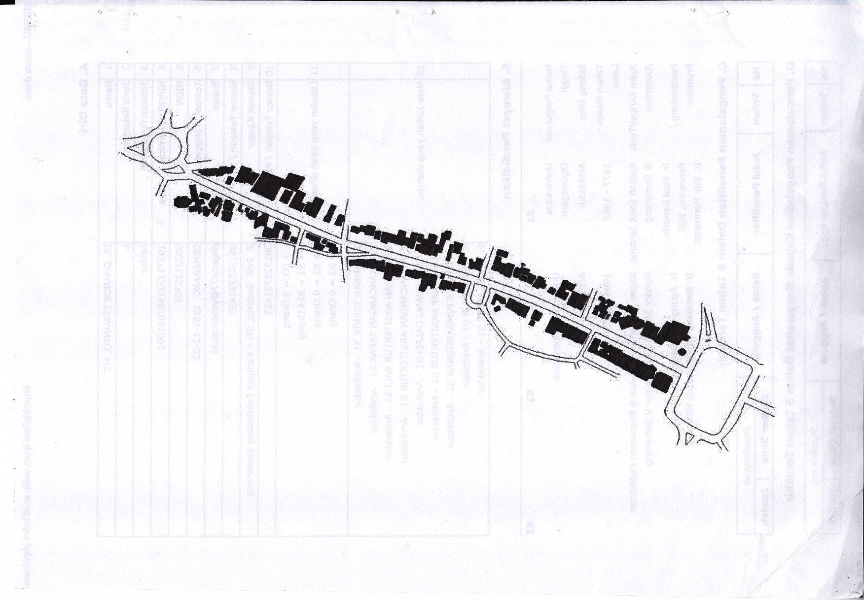
Northeast Side
Southwest Side
SEGMENT 2
SEGMENT 3
Southwest Side
Northeast Side

Fig. 9: Figure Ground in Segment 2 and Segment 3 Pandanaran Street Corridor.

The function of a mixture that is owned by the Pandanaran Street causing the buildings who were there having the different physical appearance. The form and mass buildings relating with the aspects of physical form buildings like height, postponement, closure, colour, material, fasade, scale, and force [4]. Based on it, can be seen that the buildings in Pandanaran Street Corridor had both different heights ranging from 1 floor, 2 floor to 3 floor, even more than 3 floor. A buildings for indoor services looked stand alone with railing clear and having difference high showy, while the buildings with function trade in the form of unit buildings in one whole floors 2, and buildings with function a mixture used for occupancy as well as place of business with KDB 60%. GSB in Pandanaran Street is 29 meters, where the value in accordance with rules that have been determined by the government of Semarang City.

Appearance mass buildings can be shaped, directing, being orientation, and supports elements linkage in order to strengthen the impression on the street [4]. This can be seen in the Pandanaran Street Corridor, where the buildings and the buildings structures evident give the impression that strong against corridor this road. In addition, the height of the buildings in Pandanaran Street Corridor has also specified limits height that can control high place and give the impression that interesting if viewed as visual. Entanglement visual emphasized in the establishment of the skyline city a positive, so that it will creates an unified environment between a new buildings with buildings that existing. Thus, character of a urban areas will could be maintained.

Skyline in an area not only function as an arrangement of a range of buildings of a municipality, but also have various purpose to the area. In Pandanaran Street Corridor, skyline formed is divided into three segments as follows:
- Segment 1 Pandanaran Street Corridor
Segment 1 Pandanaran Street Corridor dominated by buildings banking services and buildings shops with GSB 0 that give impression familiar. Picture of the buildings skyline at segment 1 seen that its peak was in the street adjacent to the Simpang Lima area, where in the area there is a buildings with a height of more than 3 floors, so making the impression of leading in a certain direction. The buildings are Hotel Santika on the northeast side and buildings office belong to Indosat. Both of them has a height of 12 floors and most prominent among the other buildings in the surrounding. In the middle segment 1 Pandanaran Street Corridor, picture of the buildings skyline looks modestly, even on the northeast side picture of skyline buildings look flat because dimensions and height of the buildings ranged from 1-2 floor, while in southwest side picture of the buildings skyline look high in the middle because there were @Hom Hotel with height of buildings and modestly or tend to be flat at its end since it has a buildings height between 1-4 floor. Appearance of the skyline form buildings look is more apparent in the tip of the adjacent to the Simpang Lima area, this because the attractiveness economic in the trade and services. In general, the existence of the buildings attributable to activities trade and services to attract the attention of visitors because of a signboard and a billboard. But, because they have not been for regulating and arrangement locations clear to laying a signboard and a billboard, so its existence has given atmosphere lacking pleasing for visitors, even sometimes considered disturbing. Nevertheless, as whole segments 1 Pandanaran Street Corridor give the impression of roomy because of the distance between buildings on the right left side, but the spatial impression there is still because there is a buildings with height of more than 3 floor.

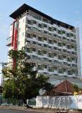
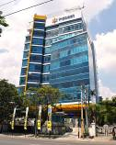
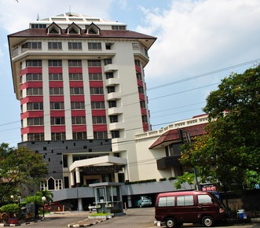
(a)
(c)
(b)

Fig. 10: (a) @Hom Hotel; (b) Hotel Santika; (c) Gedung Indosat.

- Segment 2 Pandanaran Street Corridor
On the northeast side segment 2, picture skyline of the buildings look high in the middle. Point of a view on segment 2 Pandanaran Street Corridor focused on buildings Hotel Pandanaran. With a height of 12 floors, the buildings is visible and clearly dominant than the other buildings. The existence of Hotel Pandanaran can be used as a focal point when viewed from the end of the street adjacent to Simpang Lima area. Overview skyline buildings on the southwest side look flat at the edges, because the height of the buildings ranges between 1-2 floors. The same relative height of the buildings on the southwest side end makes this area do not form a dynamic skyline. The final part tip of the southwest side of the street, buildings skyline picture looks slightly elevated because there are office buildings and trade which has a height of 3-4 floors. The existence of Pandanaran Park on the southwest side as public open space states that the other lines in the other direction. The function of Pandanaran Park in the area is not only as a room greening city, but also serves as a recreation site residents.
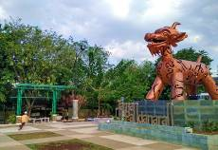
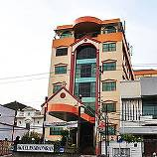
(a)
(b)

Fig. 11: (a) Pandanaran Park; (b) Hotel Pandanaran.

- Segment 3 Pandanaran Street Corridor
In northeast side segment 3, picture skyline the buildings look high on the tip of the way because their office buildings belonging to Suara Merdeka have a height of 16 floors, that look very prominent than other buildings. While in the middle at the end, picture skyline buildings at this side tending to look flat because most in the form of buildings office with the height of 3-4 floors. Existing buildings were impressed fused to each other so it looks like a series of buildings. While on the northeast side, dominated by buildings with function office the height of between 3-4 floor. At southwest side, the buildings dominated by shops buildings with various height between 1-4 floor, so that picture skyline the buildings looks more variative. On this side seen many billboards lined along the street, so that seem indicator that the area is to be special as sales center of special meal of the Semarang City, especially Bandeng Presto. Shop buildings Bandeng Presto visible very clearly on the southwest side Pandanaran Street Corridor because a billboard large enough. If seen from this shopping area, Tugu Muda can becomes as the focal point for this segment. The presence of the transverse gate is near gift shops of the area can be said containing aspects thissness because it shows that if the area is central souvenirs area typical of Semarang City.

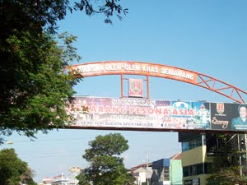
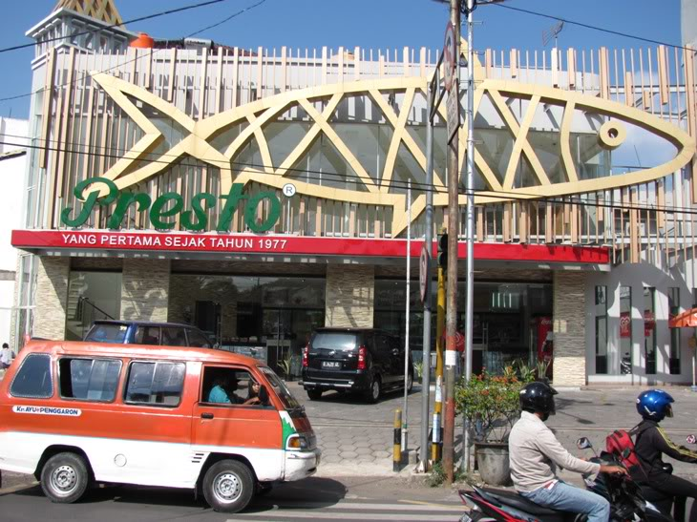
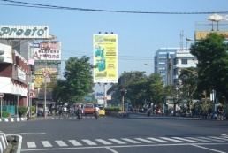
(b)
(a)

Fig. 12: (a) Billboards of Bandeng Stores; (b) Transverse Gate as a Guide Region.

4. CONCLUSION

Of various description above, it can be concluded if Pandanaran Street Corridor form a public open space that extends or forming hallway (corridor), which is equipped with the pedestrian ways. The existence of the component pedestrian ways along Pandanaran Street Corridor have a role in affirming the form of a corridor that connects a row buildings mass and trees that provide continuity of movement from Tugu Muda area to Simpang Lima area. Pandanaran Street Corridor space structures are included in a single block which is situated as part of a street line and a closed circulation system including linear. Homogeneous texture patterns, because there is only one pattern arrangement, the arrangement of buildings mass form a linear pattern (lined up on the left right side). Element vacancy demonstrated by the existence of open space is sorely lacking so powerful, because the various heights of buildings, a buildings shaped not uniform, and the buildings is relatively spacious dimensions. From the pattern of the existing buildings mass, forming the overall skyline seen varied. End of the street adjacent to Simpang Lima, seen increase because there are commercial buildings, as offices and hotels. At the midlle of the visible low, while in the street adjacent to Tugu Muda appear high on the northeast for office buildings and in the southwest look more varied because there are stores that have a height between 1-4 floor. The view is in contrast impressed Pandanaran Street Corridor and monotonous interchangeably. On the left and right side of the street lies the barrier of shade trees that can be used as element to manage. Pandanaran Street Corridor adjacent to Simpang Lima area is dominated by banking buildings services and buildings shopping with GSB 0 to give the impression of the familiar. The buildings with a height of more than 3 floor make an impression leads to a certain direction. Visually, the impression most strongly felt in the segment 3 by the presence of buildings of shops selling typical food of Semarang City is known as a center of souvenirs to Semarang. This is reinforced by a transverse gate near the local shops divide.

5. ACKNOWLEDGEMENT

The authors say thanks to all those who have helped in collecting data used in this article as a part of the objective of our research to get an overview of texture buildings in Pandanaran Street Corridor. Thanks also authors say to Engineering Faculty, Diponegoro University who has been assisting in research funding so that this research can be accomplished.

6. REFERENCES

[1] Arikunto. (2006). Procedure Research: A Practical Approach. Jakarta: PT Rineka.

[2] Cullen, Gordon. (1996). The Concise Townscape. Oxford: Butterworth-Heinemann.

[3] Rapoport, Amos. (1983). The Meaning of The Built Environment. Beverly Hills: Sage Publication.

[4] Shirvani, Hamid. (1985). The Urban Design Process. New York: Van Nostrand Reinhold Company.

[5] Sugiyono. (2008). Quantitative Research Methods, Qualitative and R & D. Bandung: CV Alfabeta.

[6] Sugiyono. (2014). Understanding Qualitative Research. Bandung: CV Alfabeta.

[7] Sumartono, Anton. (2003). Linkage Corridor Study of Pandanaran Street in Semarang City. Magister of Architecture. Engineering Faculty. Diponegoro University. Semarang.

[8] Trancik, Roger. (1986). Finding Lost Space: Theories of Urban Design. New York: Nostrand Reinhold Company.

[9] Wiharnanto, Sri. (2001). Influence Architecture Design Elements Againts Public Space User Visits Region (Case Study: Trade Center in Pandanaran Street Semarang). Magister of Architecture. Engineering Faculty. Diponegoro University. Semarang.

[10] Zahnd, Markus. (1999). Integrated Urban Design. Yogyakarta: Kanisius.

