Effects of Temperature on Survival Rate and Larval Development of Blue Swimming Crab, Portunus pelagicus (Linnaeus, 1758)

Under Laboratory Conditions

Efrizal
Departement of Biology, Faculty of Math and Science, Andalas University,
Kampus Unand Limau Manis, Padang, 25163, West Sumatera, Indonesia

*Corresponding author:

Efrizal
Departement of Biology, Faculty of Math and Science, Andalas University,
Kampus Unand Limau Manis, Padang, 25163, West Sumatera, Indonesia
Telephone no: 0751-71671
Fax no: 0751-73118
e-mail: efrizal.unand@gmail.com

Abstract
An experiment was conducted to determine the effects of temperature on survival rate and larval development of blue swimming crab, Portunus pelagicus (Linnaeus, 1758) under cultured conditions. Five different constant temperatures (26, 28, 30, 32 and 34 ºC) were compared in triplicate. The larval were fed a live diet and examined and daily and death or molts recorded. The result showed that survival rate and larval development were significantly different among treatments due to temperature (P< 0.05). ). The highest and lowest larval survival rates until C1 stages were promoted by 30 ºC (36.67 %) and 34 ºC (12.22 %). The second best survival rate of C1 (31.11 %) was obtained at 28 ºC. The lowest larval development (3.67 -4.00 days) occurred at 30-34 ºC (P> 0.05). At 26ºC and 28ºC larval development of C1 took around 5.67 days (P>0.05).

Keywords : Portunus pelagicus; larval, temperature, survival rate, development

- Introduction
Temperature is one of the most important abiotic factors affecting the growth and survival of aquatic organisms (Kumlu et al., 2000). Larval stages of most decapod species occur in full strength seawater and stable water temperatures. Hence, it is generally accepted that the decapod species are not equipped with capabilities of withstanding major environmental changes during their larval development.
Changes in the environmental conditions of the estuarine and coastal nursery areas of juvenile fish and crustaceans can affect the size of the subsequent yield of adults (Gracia and LeReste, 1981). Studies of the response of juveniles to different environmental factors can therefore lead to a better understanding of stock fluctuations and be used to develop predictive models. They can also provide information on the optimum environmental factors to maximize the reproduction of animals in culture, which is of obvious practical importance for aquaculturists.
Blue swimming crab, P. pelagicus (Linnaeus, 1758) is an Indo-Pacific species distributed along in nearshore marine and estuarine waters (Stephenson, 1962 and Kailola at al., 1993) and is one of the most important commercial species in this part of the world. In tropical region berried females, P. pelagicus spawn throughout the year (Batoy et al., 1987). Whereas, in temperate reproduction regions is restricted to the warmer months (Meagher, 1971; Smith, 1982). The eggs and the larvae of blue swimming crabs are planktonic. The eggs hatch after about 15 days at 24ºC. The larval phase consists of five stages. During the larval phases, crabs may drift as far as 80 km out to sea before returning to settle in shallow inshore waters (William, 1982). Bryars (1997) predicted the larval duration of P. pelagicus in South Australia to be about 26 to 45 days under average environmental (temperature) conditions. For this, numerous studies have been conducted on the effects of temperature on larval survival and development in many brachyuran species (Anger, 1983; Chen and Cheng, 1985; Dawirs, 1985; Minagawa, 1990; Choy, 1991; Zeng and Li, 1992; Okamoto, 1993; Hamasaki, 1996; 2003), but a few studies have examined the effects of environmental conditions on development and survival of P. pelagicus larvae under controlled laboratory conditions.
A better understanding of the effects of temperature on the larval culture of this crab is important in order to provide adequate conditions for an optimal production. The objective of the present study was to determine the development and survival of P. pelagicus (Linnaeus, 1758) at five different temperature levels during the larval development from the Z₁ to the first crab stage under laboratory conditions.

Materials and Methods
Berried blue swimming crab females, with mean body weight (BW) of 149.6 gm, and carapace width (CW) of 114.73 mm were caught from their natural habitat in nearshore marine waters of Port Dickson. They were maintained in 300L fiberglass tanks for disinfection at 100 ppm formaldehyde for 30 minutes prior to stocking in incubation and hatching tanks.
The water quality in the incubation tanks is maintained using a flow-through system (2L/min) and gentle aearation. Water temperature and salinity (measured each morning at 0900) in the tanks varied from 27 - 28ºC and 32 ppt, respectively. When hatching appeared imminent, as indicated dark ocular pigmentation and movement of the embryo inside the egg membrane, the water incoming and outcoming were stopped. Hatching occurred during both day and nighttime hours. Larvae are transferred to a separate aquarium for observation and rinsing before being placed into the experimental rearing containers.
Upon hatching, only the healthy Z₁ which swam actively near to water surface were stocked for experiment. The larvae were reared into 3 L cylindrical plastic containers at density of 30 larvae per containers. They were acclimatized to five temperature levels (26, 28, 30, 32 and 34ºC) controlled by thermostatically regulated electric heater and air conditioning unit. The water quality parameters were relatively constant throughout the duration of study. Water salinity varied from 28 to 30 ppt, dissolved oxygen was maintained above 6.0 ppm and pH was 7.8 to 8.0.
The larvae were fed Artemia nauplii at densities of 5 and 10 ind. ml⁻¹ on the first zoea and second zoea to first crab stages respectively. Rotifers and micro-alge Nannochloropsis oculata that contained essential fatty acids for larval crabs (Suprayudi et. al., 2002) were also given on the first zoea stage at 5 ind. ml⁻¹ and 5x10³ cell.ml⁻¹ , respectively. Gentle aeration provided oxygen saturation and larval suspension and sufficient turbulence to prevent settling of food organism. Larvae were transferred to newly prepared containers with new sea water and prey using a large-mouthed pipette each morning. Larva were observed and counted for survival and larval stages daily. Different stages of zoea were easily distinguished by their body size. Sunken eggs and larval stages of dead larvae were also removed daily from the bottom of the tanks by a large-mouthed pipette.

The data of survival rate (premetamorphic survival and successful metamorphosis) and duration of larval stages (days) were tested using one way ANOVA and Duncan’s Multiple Range test was used to compare the mean differences among treatments (Steel and Torrie, 1980). Arcsin transformation was done in the analysis of the data in percentage.

- Results
Premetamorphic survival and duration of each larval stage of blue swimming crab reared under different temperature conditions are summarized in Table 1. Changes in the number of respective stages of larvae with time after hatching are shown in Figs. 1 to 5. The first zoeal stage (Z₁) and second zoeal stage (Z₂) reared at 26ºC, 28ºC, 30ºC, 32ºC, and 34ºC displayed higher survival rates in the range of 90.00 to 95.56% and 77.78 to 87.78% respectively, but did not differ statistically (P>0.05). Regression analysis showed a linear relationship between temperature and premetamorphic Z1 and Z2 survival (PZ₁SR = -0.8332T + 117.8800; R² = 0.3158; P>0.05; Fig. 6, and PZ₂SR = -1.2220T + 119.1000; R² = 0.3757; P<0.05; Fig. 7, respectively). The development duration of Z1 (6.67 days) was longer at 26ºC compared to other temperature levels (P<0.05). On the other hand, at Z_{2,} temperature of 34ºC gave longer development duration (5.66 days) than the other treatments, this effect was not statistically significant (P>0.05). The relationship between temperature and development duration for Z₁ and Z₂ were quadratic (DuZ₁ = 0.1071T² - 6.6619T + 107.3700; R² = 0.8688; P<0.05; Figure 57, and cubic (DuZ₂ = 0.0174T³ - 1.5268T² + 44.4960T - 424.6100; R² = 0.3842; P>0.05; Fig. 9, respectively).
The percentage of premetamorphic survival from Z₁ to Z₃ stage increased with increasing temperature up to 30ºC and then decreased at 32ºC. Analysis of variance showed a significant effect of temperature on premetamorphic survival rate of Z₃ at 5% level of significance. A further test of significance of the differences in premetamorphic Z₃ survival means showed significant differences between treatment 34ºC and treatments 28ºC and 30ºC. While from the mean development duration of Z₃, low temperature (26-28ºC) was found to be prolonged (P<0.05) compare to high temperature (30-34ºC). The relationship between temperature and premetamorphic survival and development duration of Z₃ were quadratic (PZ₃SR = - 0.3971T² + 22.4920T - 241.3000; R² = 0.5155; P<0.05; Fig. 10, and DuZ₃ = 0.0357T² - 2.3095T + 41.1240; R² = 0.6044; P<0.05; Fig. 11, respectively).
The premetamorphic survival from Z₁ to Z₄ stages were generally high (62.22 to 66.67%) at all the temperature levels tested, with no significant differences among treatments (P>0.05). The relationship between temperature and premetamorphic survival was cubic with an equation of PZ₄SR= 0.1967T³ - 17.7820T² + 533.0600T – 5228.5000 (R² = 0.2450; P>0.05; Fig. 12). The duration of larval development showed a relatively similar pattern with the previous premetamorphic survival of Z₁, Which the low temperature (26ºC) tended to be prolonged development duration (P<0.05) compared to high temperature (28-34ºC). Regression analysis showed the relationship to be quadratic (DuZ₄ = 0.0714T² - 4.4524T + 75.9810; R² = 0.7569; P<0.05; Fig. 13). During the megalopa stage, the larvae grew best at 26ºC to 32ºC (42.22 -50.00%). High temperature of 34ºC consistently gave the lowest (P<0.05) premetamorphic survival rate of megalopa stage (30%) compared to other treatments. The relationship between temperature and premetamorphic survival for megalopa was quadratic (PMSR = 0.4366T² + 24.0850T – 283.0000; R² = 0.6286; P<0.05; Fig. 14). The longest (P<0.05) development duration was found in premetamorphic M survival held at 26ºC to 28ºC, which required an average of 8.33-8.67 days, followed by those held at 30ºC to 34ºC which required an average of 3.67 to 4.00 days. Regression analysis found the relationship to be quadratic (DuM = 0.0655T² – 4.1786T + 73.3050; R² = 0.6654; P<0.05; Fig. 15).
The influence of temperature was more evident on the successful metamorphosis and larval development duration during the first crab stages (C₁). The highest and lowest successful metamorphosis of C₁ stage were obtained at 30ºC (36.67%) and 34ºC (12.22 %) respectively. The second best successful metamorphosis of C₁ (31.11%) was obtained at 28ºC. Statistical analysis using ANOVA with DMRT test demonstrated that successful metamorphosis of C₁ reared at 34% was significantly lower (P<0.05) than those at other temperature levels. The shortest larval development duration (3.67-4.00 days) occurred at 30-34ºC at all the temperature levels (P<0.05). At 26ºC and 28ºC larval development of C₁ took around 5.67 days. The relationship between temperature and successful metamorphosis and development duration of C₁ were quadratic (SuMpC₁= -0.9326T² + 54.2340T - 754.4400; R² = 0.7630; P<0.05; Fig. 16, and DuC₁ = 0.0476T² - 3.1238T + 55.0100; R² = 0.6392; P<0.05; Fig. 17, respectively).

- Discussion
Based on the result of correlation coefficient R (Fig. 6, 7, 10, 12, 14 and 16) analysis in temperature and survival relationship; it could be explained that their relationship tended to increase from the stage Z₁ (56.19%), Z₂ (61.29%), Z₃ (71.52%), M (79.28%) and C₁ (87.35%), except for Z₄ (49.49%). For the R², survival could be explained by temperature as much as R² (%), whereas the remainder could be explained by other factors which were not considered in this research. Starting from stage Z1 to C1 the R² value were increased, except for the Z4 as follow 31.58% (Z₁), 37.57% (Z₂) , 51.55% (Z₃), 24.50% (Z₄), 62,86% (M) and 76.30% (C₁).
As can be seen from coefficient of correlation R (Figure 8, 9, 11, 13, 15 and 17) on duration of the development of the larvae, the relationship was varied as follows 93.21% (Z1), 61.98% (Z2), 77.74% (Z3), 87.00% (Z4), 81.57% (M), and 79.95% (C1). In addition, the relationship between larvae survival and the increasing of temperature were varied in every stage of development with value of R² as follow 86.88% (Z₁), 38.42% (Z₂), 60.44% (Z₃), 75.69% (Z₄), 66.54% (M) and 63.92% (C₁).
Temperature regulates many processes such as activity, feed consumption and growth in poikilotherms (Winberg, 1959). Effects of temperature on larval survival have been reported for the mud crab species S. serrata (Chen and Cheng, 1985; Zeng and Li, 1992). In this study, the survival rate and larval development of blue swimming crab were also shown to be influenced by the levels of temperature. Relatively low temperature (26ºC and 28ºC) slowed larval development but did not cause high mortality. The larvae subjected to the relatively lower temperature (26 ºC and 28ºC) displayed higher survival at each premetamorphic survival in comparison to those of higher temperature (32ºC and 34ºC). This finding agreed with those of Hamasaki (2003) who studied the effects of temperature on survival and larval development of the mud crab S. serrata reared in the laboratory. Temperature between 26 to 29ºC consistently give a better survival rate for S. serrata than temperature between 32 to 35ºC. The time taken for metamorphosis into subsequent larval stages decreased when temperature increased to 32ºC. Similar results also have been reported for the larvae of various brachyuran species (Anger, 1983; Dawirs, 1985; Minagawa, 1990; Choy, 1991; Okamoto, 1993; Hamasaki, 1996).
The best (P<0.05) survival rate to the first crab stages (C₁) was obtained at 30ºC (Table 1 and Figs. 1-5). Therefore, the optimum rearing temperature for P. pelagicus larvae was at 30ºC. Hamasaki (2003) found that the optimum temperature for survival S. serrata was 29ºC. In the same species, Chen and Chen (1985) kept their culture at three temperatures levels of 22ºC, 26ºC and 30ºC. They reported that the optimum range temperature for survival was between 26 to 30ºC. Zeng and Li (1991) also concluded that the optimum temperature for the zoea was between 25-30ºC. Anger et al. (1981) too demonstrated similars trends among another six species of brachyuran crabs (Rhithropanopeus harrisii, Panopeus herbstii, Neopanope sayi, Menippe mercenaria, Sesarma cinereum, and Libinia emarginata) and noted that the optimal temperatures for these larvae ranged between 25 to 30ºC.
In this experiment, the first crab stages reared at 28ºC displayed the second highest survival but showed longer larval development period. This fact confirms the suggestion that high temperatures to a certain optimal point increase the molting frequency but reduces the larval survival rate of penaeid shrimp (Parado-Estepa, 1998; Kumlu, 2000). This is possibly because of less protein that is being incorporated into the body tissue (Staples and Heales, 1991; O’Brien, 1994). Hill (1974) found that survival of S. serrata zoeae over the first 24 hours from hatching is higher (> 90%) at low temperature of 12-25ºC than at high temperature of 25ºC to 35ºC (50-90%). It is likely that the reduced survival rate of unfed larvae at high temperatures is due to the increased metabolic rate and rapid depletion of limited metabolic reserves rather than a consequence of heat stress.
The thermal preferences of blue swimming crab, P. pelagicus, may not be uniform throughout life, and results of this study may not be entirely applicable to all developmental stages of P. pelagicus. Blue swimming crab post larvae typically recruit into nearshore areas, where water is shallowest and temperatures highest (Kangas, 2000). As the animals develop and reach first sexual maturity, they gradually migrate to offshore where water is deeper and temperature is cooler. As such, adult blue swimming crabs may be more suited to lower temperatures than postlarvae, and the thermal requirements of later stage growing animals may need to be investigated separately. The present experiment indicated that P. pelagicus larvae would sustain maximum premetamorphic survival and successful metamorphosis rates at 28ºC to 30ºC. Larvae reared at lower temperatures (26ºC) experienced both extended intermolt periods and depressed molting increments, whereas larvae held at higher temperature (32-34ºC) seemed to maintain normal moltings, but survival rates of premetamorphic and successful metamorphosis were reduced. These findings are in general agreement with those of Whitam (1973), Lellis and Russell (1990) for Panulirus argus, Serfing and Ford (1975) for Panulirus interruptus and Hamasaki (2002) for S. serrata. Whereas temperature affected both intermolt period and molting increment in the present experiment, Serfling and Ford (1975) reported that accelerated growth at elevated temperatures was attributed solely to reduced intermolt period and not to any change in molting size increment.

Acknowledgements
Part of this research was conducted at Department of Biology, Faculty Science, Universiti Putra Malaysia. Therefore, the author thanks and appreciates to Prof. Aziz Arshad, Ph.D, Prof. Dr. Mohd. Salleh Kamaruddin and Prof. Dr. Che Roose Saad f for their help and advice during the early stages of this study.

References
Anger, K., Dawirs, R.R., Anger, V., Goy, J.W. and Costlow, J.D., 1981. Starvation resistance in first stage zoeae of brachyuran crabs in relation to temperature. J. Crust. Biol. Vol. 1, pp. 518–525.
Anger, K., (1983). Temperature and the larval development of Hyas araneus L. (Decapoda : Majidae); extrapolation of laboratory data to field conditions. . Journal of ExperimentalMarine Biology and Ecology, 203 - 215.
Batoy, C.B., Sarmago, J.F. and Pilapil, B.C. (1987). Breeding season, sexual maturity and fecundityof the blue crab, Portunus pelagicus (L.) in selected coastal waters in Leyte and vicinity,Philippines. Annals of Tropical Research, 9: 157-177.
Bryars, S.R. (1997). Larval dispersal of the blue swimmer crab Portunus pelagicus Linnaeus (Crustacea: Decapoda: Portunidae) in South Australia. Flinders University, Australia.Unpublished PhD thesis, 256 pp.
Chen, H.-C. and Cheng, J.-H., 1985. Studies on the larval rearing of serrated crab, Scylla serrata: I. Combined effects of salinity and temperature on the hatching, survival and growth of zoeae. J. Fish. Soc. Taiwan 12, pp. 70–77 (in Chinese with English abstract) .
Choy, S.C., 1991. Embryonic and larval biology of Liocarcinus holsatus and Necora puber (Crustacea: Brachyura: Portunidae). J. Exp. Mar. Biol. Ecol. 148, pp. 77–92.
Dawirs, R.R., 1985. Temperature and larval development of Carcinus maenas (Decapoda) in the laboratory; predictions of larval dynamics in the sea. Mar. Ecol., Prog. Ser. 24, pp. 297–302.
Garcia, S., and L. LeReste, 1981. Life cycles, dynamics, exploitations and management of coastal penaeid shrimp stocks. FAO Fish. Tech. Pap., No. 203, 215 pp.
Hamasaki., K., 1996. Study on the reproduction and development of the swimming crab, Portunus trituberculatus. Special Scientific Report of Japan Sea-Farming Association 8. 124 pp. (in Japanese with English summary).
Hill, 1974. B.J. Hill, Salinity and temperature tolerance of zoeae of the portunid crab Scylla serrata. Mar. Biol. 25 (1974), pp. 21–24.

____________, 2003. Effects of temperature on the egg incubation period, survival and developmental period of larvae of the mud crab Scylla serrata (Forskål) (Brachyura: Portunidae) reared in the laboratory. Aquaculture 219, pp. 561- 572.
Kailola, P.J., Williams, M.J., Stewart, P.C., Reichelt, R.E., McNee, A., Grieve, 1993. Australian Fisheries Resources. Bureau of Resource Sciences, Department Industries and Energy, and the Fisheries Research and Development Corporation, Canberra, Australia.
Kumlu, M., Eroldogan, O.T., and Aktas , M., 2000. Effects of temperature and salinity on larval growth, survival and development of Penaeus semisulcatus. Aquaculture 188 : pp. 167-173.

Lellis, W.A., and J. A. Russell. 2000. Effect of temperature on survival, growth and feed intake of postlarval spiny lobsters, Panulirus argus. Aquaculture 90: 1-9.
Meagher, T.D., 1971. Ecology of the crab Portunus pelagicus (Crustacea Portunidae) in south western Australia. University of Western Australia. Unpublished PhD thesis, 232 pp.
Minagawa, M., 1990. Influence of temperature on survival, feeding and development of larvae of the red frog crab, Ranina ranina (Crustacea, Decapoda, Raninidae). Nippon Suisan Gakkaishi 56, pp. 755–760.
O’Brien, C.J. 1994. The effects of temperature and salinity on growth and survival of juvenile tiger prawn Penaeus esculentus. Journal of Experimental Marine Biology and Ecology 183 (1): 133–145.
Okamoto, K., 1993. Influence of temperature on survival and growth of larvae of the giant spider crab Macrocheira kaempferi (Crustacea, Decapoda, Majidae). Nippon Suisan Gakkaishi 59, pp. 419–424.
Parado-Estepa, F.D. 1998. Survival of Penaeus monodon postlarvae and juveniles at different salinity and temperature levels. The Israeli Journal of Aquaculture 50 (4): 174–183.
Serfling, S.A., and R.F. Ford. 1975. Laboratory culture of juvenile stages of the California spiny lobster Panulirus interruptus (Randall) at elevated temperatures. Aquaculture 6 : 377–387.
Smith, H., 1982. Blue crabs in South Australia-their status, potential and biology. Safic, Vol.6, pp6-9.
Staples, D.J., Heales, D.S. 1991. Temperature and salinity optima for growth and survival of juvenile banana prawn Penaeus merguiensis. Journal of Experimental Marine Biology and Ecology 154: 251–274
Steel R.D.G., and J.H. Torrie., 1990. Prinsip dan prosedur statistic. PT. Gramedia Jakarta. 748 halaman.
Stephenson, W., 1962. Evolution and ecology of portunid crab, with special reference to Australian species. In: The evolution of living organisms (ed.Leeper, G.W.), Melbourne University Press, Melbourne, pp 311-327.
Suprayudi, M.A., Takeuchi, T., Hamasaki, K. and Hirokawa, J., 2002. The effect of n-3HUFA content in rotifers on the development and survival of mud crab. Scylla serrata, larvae. Suisanzoshoku 50, pp. 205–212.
Williams, M.J. (1982). Natural food and feeding in the commercial sand crab P. pelagicus Linnaeus,1766 (Crustacea: Decapoda: Portunidae) in Moreton Bay, Queensland. Journal of ExperimentalMarine Biology and Ecology, 59: 165-176.
Witham, R. 1973. Preliminary thermal studies on young Panulirus argus. Fl. Sci. 36:154–158.
Zeng C. and Li, S., 1992. Effects of temperature on survival and development of the larvae of Scylla serrata. J. Fish. China 16, pp. 213–221 (in Chinese with English abstract).

Caption of tables and figures

Table 1: Survival rate (% premetamorphic survival* and successful metamorphosis**) and development duration (days) of different stages of zoea (Z1-Z4*), megalopa (M*), and first crab (C1**) of blue swimming crab, P. pelagicus, reared under different temperature. Value within a given column with different superscripts are significantly different (P<0.05). Values are means ± standard errors from three replicate groups of larvae of the P. pelagicus (means ± SE, n = 3), Du, development duration of larval stages (days); initial number: 90 zoea.

Fig. 1: Percentage survivorship and stage of larvae P. pelagicus reared at 26ºC.
Fig. 2: Percentage survivorship and stage of larvae P. pelagicus reared at 28ºC.
Fig. 3: Percentage survivorship and stage of larvae P. pelagicus reared at 30ºC.
Fig. 4: Percentage survivorship and stage of larvae P. pelagicus reared at 32ºC.
Fig. 5: Percentage survivorship and stage of larvae P. pelagicus reared at 34ºC.
Fig. 6: Relationship between temperature (T) and premetamorphic Z₁ survival (PZ₁SR) of P. pelagicus larvae.
Fig. 7: Relationship between temperature (T) and premetamorphic Z₂ survival (PZ₂SR) of P. pelagicus larvae.
Fig. 8: Relationship between temperature (T) and development duration of P. pelagicus Z₁ larvae (DuZ₁).
Fig. 9: Relationship between temperature (T) and development duration of P. pelagicus Z₂ larvae (DuZ₂).
Fig. 10: Relationship between temperature (T) and premetamorphic Z₃ survival (PZ₃SR) of P. pelagicus Z₃ larvae.
Fig. 11: Relationship between temperature (T) and development duration of P. pelagicus Z₃ larvae (DuZ₃).
Fig. 12: Relationship between temperature (T) and premetamorphic Z₄ survival (PZ₄SR) of P. pelagicus larvae.
Fig. 13: Relationship between temperature (T) and development duration of P. pelagicus Z₄ larvae (DuZ₄).
Fig. 14: Relationship between temperature (T) and premetamorphic M survival (PMSR) of P. pelagicus larvae.
Fig. 15: Relationship between temperature (T) and development duration of P. pelagicus M larvae (DuM).
Fig. 16: Relationship between temperature (T) and successful metamorphosis of P. pelagicus C₁ larvae (SuMpC₁).
Fig. 17: Relationship between temperature (T) and development duration of P. pelagicus C₁ larvae (DuC₁).

Table 1.
Temperature | Variable | Z₁ | Z₂ | Z₃ | Z₄ | M | C₁
26ºC | % ± SE | 95.56 ± 2.72ª | 87.78 ± 2.72ª | 74.44 ± 3.60^{ab} | 62.22 ± 2.72ª | 50.00 ± 2.36ª | 25.56 ± 3.60^{b}
 | Du ± SE | 6.67 ± 0.41^{A} | 5.33 ± 0.41^{A} | 5.00 ± 0.00^{A} | 8.67 ± 0.41^{A} | 8.67 ± 0.41^{A} | 5.67 ± 0.41^{A}
28ºC | % ± SE | 95.56 ± 1.36ª | 83.33 ± 4.08ª | 77.78 ± 1.36ª | 65.56 ± 2.72ª | 44.44 ± 4.91ª | 31.11 ± 3.60^{ba}
 | Du ± SE | 4.67 ± 0.41^{B} | 5.33 ± 0.41^{A} | 5.00 ± 0.00^{A} | 7.00 ± 0.00^{B} | 8.33 ± 0.41^{A} | 5.67 ± 0.41^{A}
30ºC | % ± SE | 93.33 ± 2.36ª | 84.44 ± 5.44ª | 77.78 ± 5.93ª | 66.67 ± 6.24ª | 48.89 ± 3.60ª | 36.67 ± 2.36ª
 | Du ± SE | 4.00 ± 0.00^{B} | 5.00 ± 0.00^{A} | 3.67 ± 0.41^{B} | 6.67 ± 0.41^{B} | 6.33 ± 0.41^{B} | 3.67 ± 0.41 ^{B}
32ºC | % ± SE | 90.00 ± 2.36ª | 78.89 ± 3.60ª | 68.89 ± 2.72^{ab} | 56.67 ± 2.36ª | 42.22 ± 3.60ª | 23.33 ± 4.71^{b}
 | Du ± SE | 4.00 ± 0.00^{B} | 4.67 ± 0.41^{A} | 3.67 ± 0.41^{B} | 7.00 ± 0.00^{B} | 6.67 ± 0.41^{B} | 3.67 ± 0.41^{B}
34ºC | % ± SE | 90.00 ± 4.71ª | 77.78 ± 1.36ª | 65.56 ± 2.72^{b} | 63.33 ± 4.71ª | 30.00 ± 4.08^{b} | 12.22 ± 1.36^{c}
 | Du ± SE | 4.67 ± 0.41^{B} | 5.67 ± 0.41^{A} | 4.00 ± 0.00^{B} | 7.00 ± 0.00^{B} | 7.00 ± 0.00^{B} | 4.00 ± 0.00^{B}

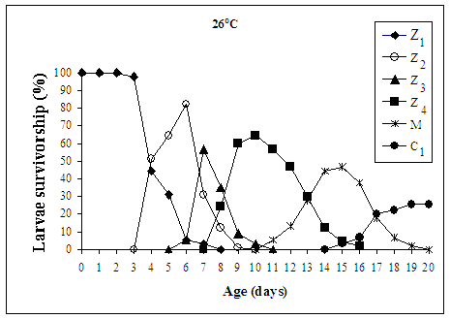
Fig. 1

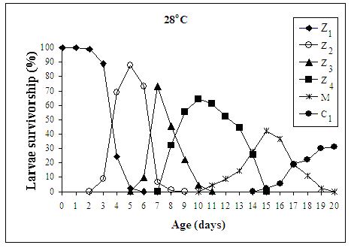
Fig. 2

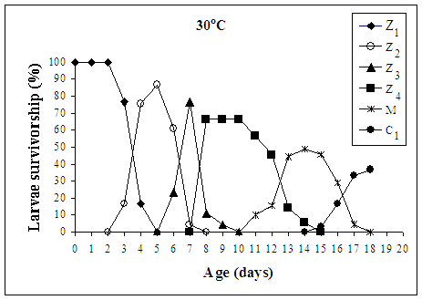

Fig. 3

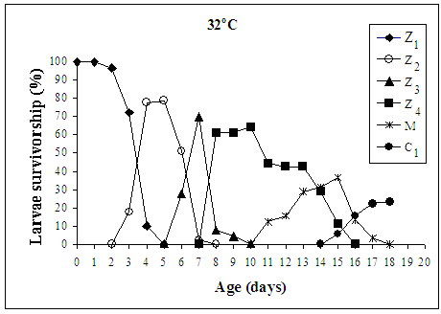

Fig. 4

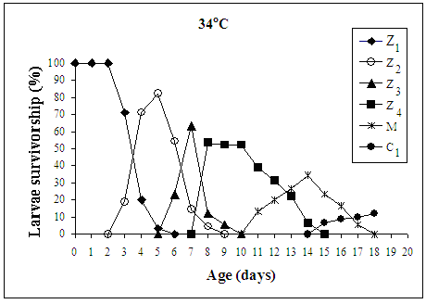

Fig. 5

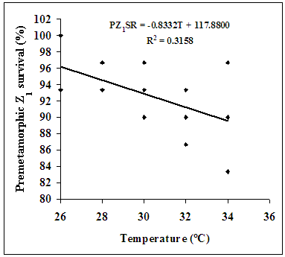

Fig. 6

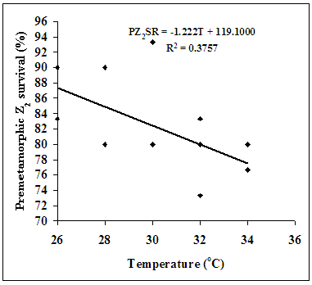
Fig. 7

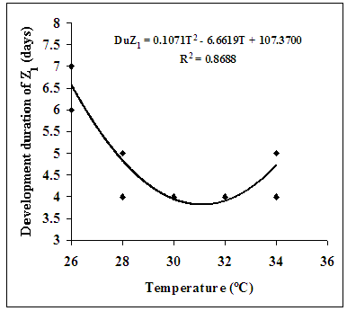

Fig. 8

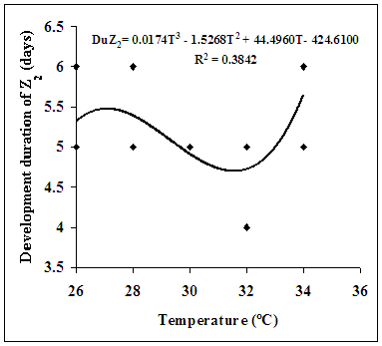
Fig. 9

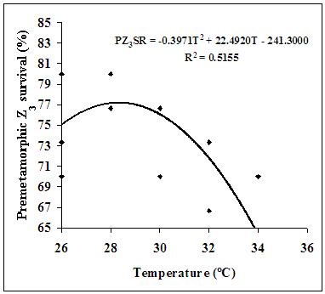
Fig. 10

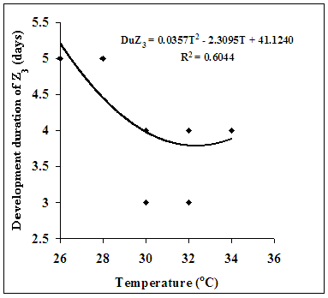

Fig. 11

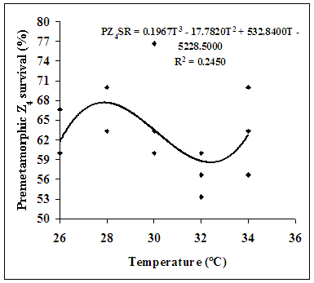
Fig. 12

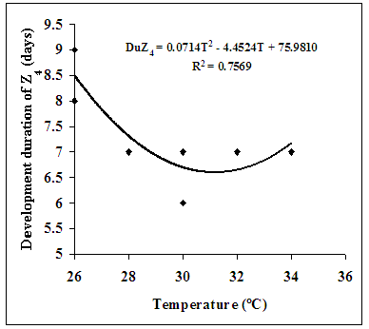

Fig. 13

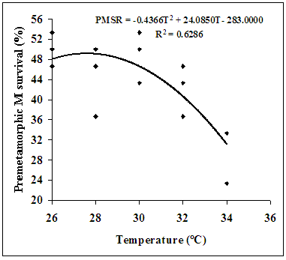
Fig. 14

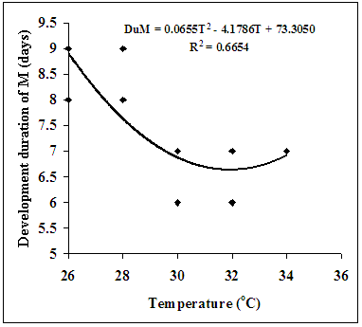

Fig. 15

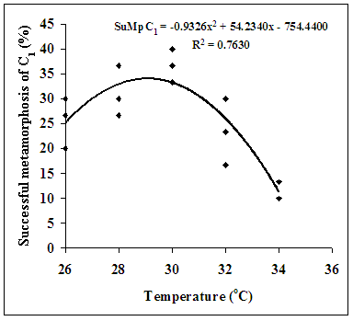
Fig. 16

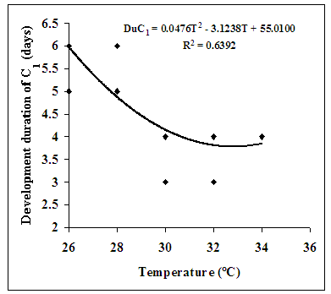

Fig. 17

