Figures
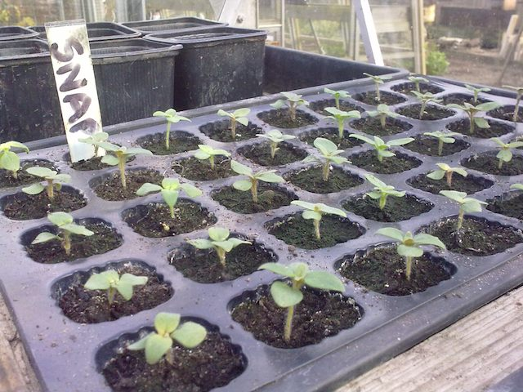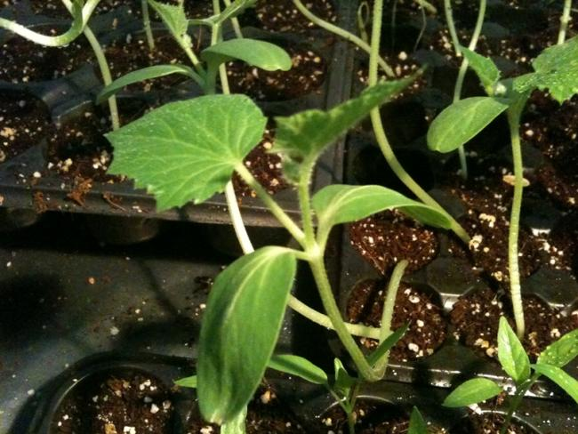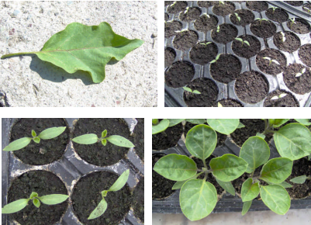
(a) (b) (c)

Figure 1. a-Bean seedling; b-cucumber seedling; c-Eggplant seeding

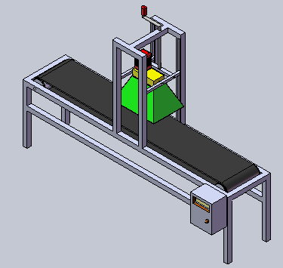
Figure 2. Microwave test unit
Figure 4. Schematic view of the change of subject terms in 700 W- 15 cm -20 sn

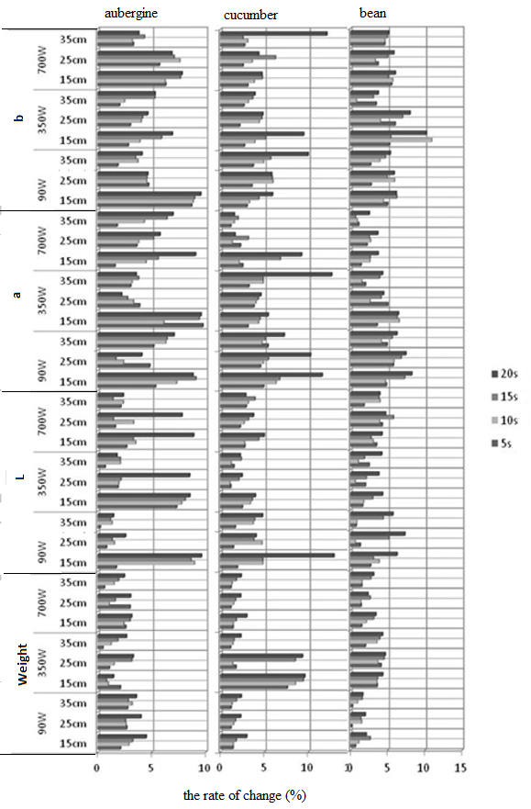

Figure 3.Microwave effect on cucumber plants eggplants, beans, (L, a, b, weight change)

