Format for Preparation of Paper for Publication in the AJPNMS
First Author’s Name¹, Second Author’s Name² and Third Author’s Name³

¹ First Author’s Affiliation
Address (City, Country)
First Author’s Email Address

² Second Author’s Affiliation
Address (City, Country)
Second Author’s Email Address

³Third Author’s Affiliation
Address (City, Country)
Third Author’s Email Address

ABSTRACT— In this paper, we describe the submission guidelines for preparing papers for the Asian Journal of Pharmacy, Nursing and Medical Sciences (AJPNMS). Use this document as a template with Microsoft Word 6.0 or later. Define all symbols used in the abstract. Do not cite references in the abstract. The abstract body is typed in Times New Roman, 10 pt. italic and in bold face.

Keywords— About four key words or phrases in order of importance, separated by commas

INTRODUCTION
The entire manuscript, including mathematical equations, tables, and figures must be prepared in electronic form and submitted as Word for Windows files. Use only fonts that come with Windows software. For the text use Times New Roman size 10. For all special characters (e.g., Greek characters) use the font Symbol. Line spacing is single; spacing after paragraphs is 6 pt; first line is indented .2 inches; text alignment is justified. Use carriage returns only to end headings and paragraphs, not to break lines of text. Verify the correct spelling for the final version with the Spelling and Grammar function of Word.
In the Introduction section, present clearly and briefly the problem investigated, with relevant references. The main results should be enunciated.

PAGE SIZE
All material on each page should fit within a rectangle of 18 x 23.5 cm (7" x 9.25"), centered on the page, beginning 2.54 cm (1") from the top of the page and ending with 2.54 cm (1") from the bottom. The right and left margins should be 1.9 cm (.75”).

Main title
The main title (on the first page) should be centered, and in Times New Roman 18-point, boldface type. Capitalize the first letter of nouns, pronouns, verbs, adjectives, and adverbs; do not capitalize articles, coordinate conjunctions, or prepositions (unless the title begins with such a word). Please initially capitalize only the first word in (for example, “Format for Preparation of Paper for Publication in the AJCIS” — as in these guidelines).

Headings and Footnotes
Primary headings are numbered; font size 11; center-justified; bold; line spacing is single; spacing before and after paragraphs are 6 pt; and in title case, i.e., with all letters capitalized.
Major headings are to be column centered in a bold font without underline. They need be numbered. "2. Headings and Footnotes" at the top of this paragraph is a major heading.
- Subheadings
Subheadings should be as the above heading “4.1 Subheadings”. Subheadings are numbered; font size 11; center-justified; bold; line spacing is single; spacing before and after paragraphs are 6 pt; and capitalize the first letter of nouns, pronouns, verbs, adjectives, and adverbs; do not capitalize articles, coordinate conjunctions, or prepositions (unless the title begins with such a word). They should start at the left-hand margin on a separate line.

Author name(s) and affiliation(s)
Author names are to be centered beneath the title and typed in Times New Roman 11-point, non-italic, non-boldface type. Multiple authors may be shown in a two or three-column format, with their affiliations below their respective names. Affiliations are centered below, typed in Times New Roman 10-point non-italic, non-boldface. Include e-mail addresses if possible typed in Times New Roman 10-point italic, non-boldface. Follow the author information by two blank lines before main text.

Main text
Type your main text in 10-point Times New Roman, single-spaced with single line spacing. Do not use double-spacing. The spacing before and after paragraphs is 6 pt. All paragraphs should be indented by 0.2”. Be sure your text is fully justified—that is, flush left and flush right. Please do not place any additional blank lines between paragraphs.
Figure and table captions should be 10-point Times New Roman non-boldface. Initially capitalize only the first word of each figure caption and table title. Figures and tables must be numbered separately. For example: “Figure 1: UML Sequence Diagram for Heath Information Service”, “Table 1: Input data”. Figure captions are to be below the figures. Table titles are to be centered above the tables.

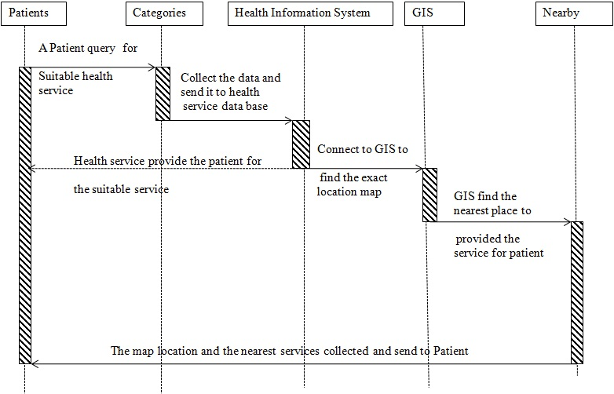
Figure 1: UML Sequence Diagram for Heath Information Service

Table 1: Project selection matrix rules
if Project strength is | And Project attractiveness is | Then the project rank is
Low  Low  Low  Medium  Medium  Medium  High  High  High | Low  Medium  High  Low  Medium  High  Low  Medium  High | Low  Low  Medium  Low  Medium  High  Medium  High  High

AcknowledgEment
The preferred spelling of the word “acknowledgement” in America is without an “e” after the “g”. Avoid the stilted expression, “One of us (R. B. G.) thanks . . .” Instead, try “R. B. G. thanks”.

References
List and number all bibliographical references in 10-point Times New Roman, single-spaced, at the end of your paper. For example, [1] is for a journal paper, [2] is for a book and [3] is for a conference (symposium) paper.

- Author1_Name, Author2_Name, “Paper Title ACASH: An Adaptive Web Caching method based on the Heterogeneity of Reference Characteristics”, Journal of AICIT, AICIT(Publication_Name), vol. 10, no. 4, pp.169-711, 2015.
- Author1_Name, Author2_Name, Web Caching and Replication, Addison-Wesley(Publication_ Name), USA, 2014
- Author1_Name, Author2_Name, “Exploring the bounds of Web latency reduction from caching and prefetching”, In Proceeding(s) of the AICIT Symposium(Conference) on Internet Technologies, pp.13-22, 2009.

